Module 6

Presentations using
OpenOffice Impress

Module Overview
Welcome to Module 6 – Presentations using OpenOffice Impress.
This module explores the building of a presentation using OpenOffice 3.0 Impress. The module is intended to be very hands-on and focus on design principles for presentations in addition to the nuts and bolts of using the Impress application.


Upon completion of this unit you will be able to:

- Understand principles of design and apply them to presentations
- Work with presentations in OpenOffice 3.1 Impress and save them in different file formats
- Choose built-in options such as the Help function within the application to enhance productivity
- Understand different presentation views and when to use them, choose different slide layouts and designs
- Enter, edit and format text in presentations. Recognise good practice in applying unique titles to slides
- Choose, create and format charts to communicate information meaningfully
- Insert and edit pictures, images and drawn objects
- Apply animation and transition effects to presentations
- Print a presentation (output a presentation to print)

Terminology

 | Type style | The choice of type face (font, size, case and block type).
 | Notes View | An Impress view that provides an image of the slide at the top of the page and allows you to input notes at the bottom of the screen.
 | Slides Workspace View | The Slides Workspace View displays miniature versions of the slides.
 | Handout View | The Handout View provides a visual of the presentation on printed pages.
 | Master view | Master View allows you to create a presentation with different types of slides but enable them to all have the same “look”.
 | 

Study Tips

You may find it useful to skim through an entire block of content first, paying special attention to the headings and introductions, and then go through a second time for more in-depth study and practice.

However, we recommend that you do the activities as they appear. They are essential study materials, offering practice in particular skills that will build your proficiency in creating effective presentations.

Keep linking the new content that you are studying with content in this module that you have already covered and with your own general knowledge, to deepen your understanding of the operations you are learning.

If you have difficulty understanding any area, try working at it slowly. If you still do not understand, seek help.


Preknowledge

Before beginning this module, we recommend you:

- study modules 1, 2 and 3 before this one, because they provide the essential knowledge for you to work with Impress, including saving files, formatting text and retrieving information from other files.
- reflect on professional presentations you have seen or given previously. What made these presentations effective, or not effective? How could these presentations have been made more meaningful to the audience?

Introduction to Presentations

Section Overview

In this section you will be introduced to what presentations are and you will be able to apply design principles in developing your presentation.

By the end of this section you will be able to:

- apply design principles to presentations and slides
- follow the design process to present a good presentation
- consider features that makes a good presentation


What is a good presentation?

The main purpose of creating a presentation is to:

- show a message in key points
- enhance the message with multimedia, i.e. text, graphics, animations and sound

A presentation has the advantages of:

- increasing the understanding of a message and reducing confusion
- increasing audience involvement
- drawing the audience attention to key points
- making a presentation more interesting
- guiding the presenter through a presentation, assist him/her to keep to the time allocated for a presentation and giving him/her a feeling of confidence and control

The disadvantages of using a presentation are:

- too many or using the wrong animations
- sound, colour and graphics create confusion and pull the attention away from the main message
- multimedia entertains without enhancing the message
- the presenter focuses on the screen, reads long parts from the screen and loses contact with the audience
- it gives too much information

Design principles

Depending on the purpose and audience of the presentation, there are a few considerations in the design of presentations:

- all slides should be well designed to fit the specific purpose and audience
- using excessive animations is distracting; unless it fits the purpose avoid them
- do not use sounds in the transition of slides, unless you want to create a specific effect. Avoid sound effects in formal presentations.
- graphical images explain more than words alone; use them when you can
- where there are generally accepted abbreviations and acronyms use them to minimise text usage
- ensure that your choices of colours are legible from a distance. Light fonts on dark backgrounds are good for textual material, but scientific graphs often work better on a light background. Keep the background colour simple.
- use the right type-faces and fonts, emphasising with bold-face or different colours. It is advisable though to keep the colours on your screen to a maximum of four.
- use descriptive headings. Don’t let your audience guess or experience difficulties in deciphering the meaning or purpose of a slide. Use of descriptive headings not only asserts the reader with the slide, but also leads to fewer slides.
- use short, concise phrases
- make use of bullet points. Golden rule is no more than five bullets per slide, then it becomes too much.
- make use of numbered lists. The same rule for bullets applies for numbers – less is more. Do not use more than five numbers per slide.

The Design Process

To create and convey a successful presentation you need to:

- plan carefully:
  - What do you want the audience to know once you have finished the presentation?
  - What do you want the audience to believe once you have finished the presentation?
- do your research
- know your audience
- time your presentation
- practice your presentation
- speak comfortably and clearly

Purpose of the Presentation

Presentations are an effective way to communicate or sell an idea to a large crowd of people at the same time. However, it is not just about communicating information or selling ideas. Determining the purpose of your presentation involves finding answers to the following questions among others:
- Why do you want to make a presentation?
- What do you want to communicate?
- What do you aim at achieving with the communication?
- Do you really need to use a presentation to achieve this?

Content

Now that you’ve focused the presentation towards its purpose, you need to find the facts that will support your point of view or the action you propose. Keep in mind you should give the audience only the facts necessary to accomplish your goals; too much information will overwhelm the audience, and too little information will leave the audience either with a sketchy understanding of your topic or with the feeling that you have not provided enough information to support the course of action you wish the audience to take.

Analyse the Audience

The most important step in designing an effective presentation is to focus on what your audience needs to know, not what you know. You now need to analyse your audience so that you can tailor your presentation to suit your specific audience’s needs and characteristics.

How to analyse your audience:

- determine your audience’s level of experience or knowledge regarding your topic
- determine the general education level and age of your audience
- determine the audience’s attitude toward the presentation topic, and based on that attitude, determine any concerns, fears, or objections your audience might have regarding the topic
- determine whether there are subgroups in the audience that might have difference concerns or needs
- formulate questions that you could ask your audience regarding the topic
- check the cultural, social and political background of your audience
- determine the audience’s motivation to attend your presentation

To have advanced presentation skills you should be able to not only instill a trust between you and your audience, but also create an interest and excitement in your audience for what you are presenting.

Structure the Presentations

A hierarchical structure organises information from more-general to more specific dimensions, so that information at the top of the hierarchy is more general than information at the bottom. And it is advisable to use such a structure when creating your presentations.

A hierarchical structure is used:

- to comprehend information – the more marked the hierarchical structure, the easier it is for us to understand
- to commit information to memory and later retrieve it
- to decide about the importance of information – we assume information at the top of the hierarchy is more important than lower information, so we pay more attention to it and learn it better

Also remember to add an introduction and conclusion to your presentation. The introduction is key to an effective presentation.

Introductions should have the following components:

- background and motivation
- objective (of the briefing or the research in general)
- an overview or outline of the rest of the briefing

The conclusion at the end will give an overview of findings, recommendations and implications. Typically in the conclusion will be a way forward. The conclusion can be more than one slide.

Rehearse the Presentation

When creating a presentation, remember to keep it short and visual so that it guides you and keeps your audience captive and focused. This way it would also be easier for you to prepare for the presentation.

When rehearsing your presentation, you need to have a clear understanding of the message you want to bring across to your audience and what you want their reaction to be. Prepare well in advance, and avoid rehearsing directly before your presentation. Remember to proofread your presentation, or have it proofread by someone else.

Typographical Considerations

The typographical issues that you should consider in your presentation are:

- type style (font)
- type size
- upper or lower case
- formatting types (Bold, Italics, Underline)

Type Style

There are significant differences in the choice of typefaces between printed information and a presentation. While a serif typeface like Garamond might look presentable on paper, on a presentation it can be difficult to read. Sans serif fonts generally look better on computer displays and presentations than serif fonts (serifs are the little hooks on the ends of letters).

Serif  (Garamond 36 point) | Sans Serif  (Verdana 28 point)

Also depending on the audience and the purpose of the presentation, some fonts might be more suitable than others. For example, for formal or official presentations, Arial would be suitable while Comic Sans might be suitable for a very informal presentation.

Arial | Comic Sans

Type Size

Depending on the audience and the presentation room, some font sizes might be more legible than others. It is always important to consider the room where the presentation will take place when choosing the size. In large rooms, with the audience seated a distance from the projection screen, large font sizes will be better than small ones.

Upper or Lower Case

Although upper case letters might be good to emphasise a point, their use should be sparing or avoided. Upper case letters occupy more space on the slide and are slow to read. For some audiences, the use of all upper case characters might be perceived as “SCREAMING”.

Formatting Types (bold, italics, underline)

Bold face makes letters more readable and appears clearer when projected on a screen.

Italics are slow to read especially from a distance and should be avoided or used sparingly.

Underlining is not very effective in a presentation and must be avoided. Use other means such as size, colour, bold to emphasise your main points.

Colour Considerations

Colour can have a great impact on the effectiveness of a presentation, and so colour choice deserves some thought. Improper use of colour can affect readability, recognition, retention and communication. Some colours are perceived to have meanings in different cultures and therefore their use should be in accordance to those cultures. Colour has also been used to evoke moods or states of mind. Some people also believe that colour enhances their learning.

While it is important to choose a colour theme that is line with your organisation’s colours, it is important to consider these other issues:

- colour contrast
- background effects
- colour blind people

Colour Contrast

Highly contrasting colours improve the readability of the slides. Care, however, should be taken not to use very sharp colours as they are tiring to the eyes.

Background Effects
Bright backgrounds can also be tiring to the eyes when a presentation is displayed using an overhead projector, since the bright light used by these projectors is reflected back to the audience.

Consider the following colour schemes:

Colour Combination | Description
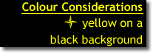 | This is arguably the easiest colour combination to read and that’s why it is widely used for caution signs. However, because the contrast is so stark, it does not look appealing on a presentation.
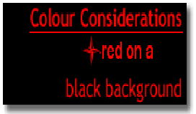 | This colour combination is almost illegible. Although the contrast is there, the mix of the colours is not right.
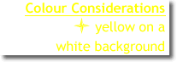 | This colour combination doesn’t have enough contrast. It is very difficult to read, and also monotonous.
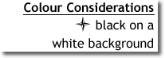 | This combination is widely used, especially for formal presentations. This combination looks good on a computer screen but the background may be too bright for a projector.
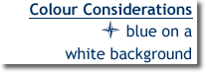 | For organisations with blue as one of their colours, this colour combination is not only legible but also creates a soothing mood. Again, the white background may be too bright for a projector.
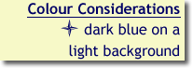 | Using a light pastel background with dark text provides a good contrast of colours that’s easier on the eyes than a white background.

Consideration for Colour Blind People

If part of your audience consists of colour blind people (estimated as 0.5% of women and 8% of men), consider that most of them have difficulty with red, green and brown. Avoid using these colours together in a presentation.

Graphics and illustrations

It is important to include visual elements to break the monotony and to illustrate important points. Graphics and illustrations are visual representations of the discussion and can greatly improve understanding and retention. Charts and graphs can help illustrate technical data or trends, and can be easily incorporated into your presentations.

Consider the following when using graphics or illustrations:

- choose images that help support the content rather than just decorate the page
- use text to augment the graphic, not dominate it
- graphics should be easily viewable and not too complex. For complex illustrations, show the illustration in its entirety, then zoom in to see the key features, or simplify the graphic by cutting out nonessential elements
- charts and graphs are excellent ways to display numerical information or trend data (for example, changes over time)
- limit graphics to one or two per page
- try to avoid using too much movement in transition of graphs and charts. When using photos or drawings, animation might be effective
- avoid using sound effects unless it is effective and needed.

On the Day of Presentation

- Make sure you are fully prepared. Gather all the relevant information to enable you to answer all the questions that might arise from your presentation.
- Make sure that the technology you are going to use is in working order and all connecting cables, remotes, spare batteries for the remote etc. are available in the venue.
- When using visual aids, use them effectively. Avoid a lot of concentration on the visual aids, focus on your audience.
- Show a lot of confidence when presenting.
- Know the occasion and dress appropriately. The way you dress can distract the audience from the presentation.
- Always maintain eye contact with the audience.
- Make sure you are audible, and clear.
- Maintain an appropriate tone and pace.
- Ensure that there is a smooth transition from point to point during your presentation.

Most Common Mistakes in Presentations

Avoid these common mistakes:

- Illegible content – Slides that contain information that is not easily readable force the audience to try and guess what is written. Audiences tend to lose interest in the presentation if they cannot see what is being presented.
- Poor organisation – Slides that are poorly organised make it difficult for your audience to understand the message of your presentation. Information that is poorly ordered is disruptive for the presenter and intimidating for the audience.
- Information overload on a slide – Too many details on a slide is intimidating and detracts from comprehension and retention of the information in the slide.
- Typographical and spelling errors – “typos” and spelling errors undermine your audience’s confidence in you and detract from the message of your presentation.
- Irrelevant colour, sounds, graphics and animation. Avoid what is called “bells and whistles”.


Summary

In this section you have been introduced to presentations and good design principles in developing your presentation. You have to remember these principles throughout this module and whenever you are developing slides to present.

You can now confidently:

- apply design principles to presentations and slides
- follow the design process to present a good presentation
- consider features that makes a good presentation

Using the Application

Section Overview

In this section you will be introduced to the overall look and feel of the Impress Window layout and how to work with presentations.

By the end of this section you will be able to:
- understand the Impress Window layout
- save a presentation and exit Impress
- navigate through slides
- set up user preferences in the application
- use the magnifying tools/zoom
- use the help function

Working with Presentations

Impress Window Layout

When you launch Impress, a new, blank document, or default window, opens. Shown below is the OpenOffice Impress default window.

It shows the three main working areas of the Impress window, viz. Slides pane, Workspace and Task pane as well as different ribbons and toolbars across the window.
Title Bar
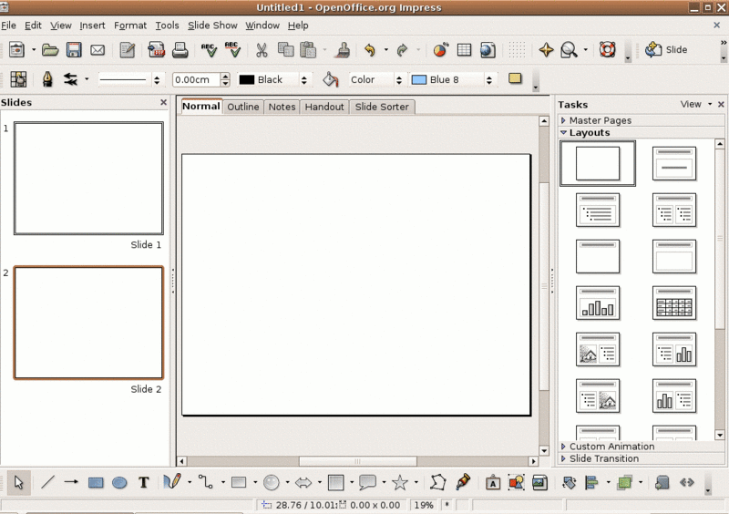
Page View Buttons
Task Pane
Workspace
Slide Pane
Menu Bar

Here is a brief explanation of the Impress window.

Title Bar

The title bar is the upper most band on your OpenOffice Impress window.

The Title bar displays both the name of the presentation and the name of the application.
- The name of the presentation is Proposal to Funders.odp (hence the “Proposal to Funders” in the title).
- The name of the application is OpenOffice Impress (hence the name OpenOffice.org Impress).

Menu bar

The Menu bar is made of text menus displayed below. The Menu bar displays all the tools that are available in Impress. Each button displays a text menu (dropdown menu) when clicking on it.


Tip: A menu in computer language is a list of choices from which a user can select. In OpenOffice Impress, you can display the contents of any menu item by clicking on the menu name with the left mouse button.

Other Toolbars

A Toolbar contains commands that have pictures or icons associated with them. These pictures may also appear as shortcuts in the Menu Bar:

Tip: The Toolbar is a row/s of icons usually on the top of the screen, just below the menu bar. The icons usually represent the frequently used commands that are activated when the icons are clicked.


Changing toolbars

There are several toolbars built into Impress. These are:

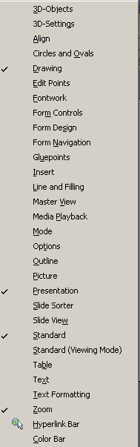

You can:
- display toolbars by ticking them off on the dropdown menu
- hide toolbars by un-ticking them on the dropdown menu
- move toolbars around by grabbing the toolbar handle on the left side of the toolbar and dragging it. You can dock them somewhere else or leave them floating in the Workspace.
- close toolbars by dragging them into the workspace and press the on the toolbar

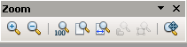

Task Pane

The Task pane, which by default appears on the right hand side of OpenOffice Impress, provides you with cascading menu options for:
- Master Pages (choice of 28 slide masters)
- Layouts (choice of 20 layouts)
- Table Design (choice of 11 standard tables)
- Custom Animations (a variety are listed and can be changed or removed later)
- Slide Transitions (56 transitions are available, you can change the speed or to do it manually/automatically and timing of automatic transition)
Any one of the menu options can be maximised by clicking on the . The menu with the displays the full menu.

To close the task pane, click on the or untick on ViewTask Pane. To restore the task pane, tick Taskpane on ViewTask Pane.

Slides Pane

The Slides pane contains thumbnail pictures of the slides in your presentation; in the order they will be shown. Clicking on a slide in the Slides pane selects it and places it in the Workspace. While it is there, you can apply any changes desired to that particular slide.

Several operations can be performed on one or more slides in the Slides pane:
- add new slides at any place within the presentation after the first slide
- mark a slide as hidden so that it will not be shown as part of the slide show
- delete a slide from the presentation if it is no longer needed
- move slides around

To close the slides pane click on the or untick on ViewSlide Pane.

To restore the task pane, tick Taskpane on ViewSlide Pane.

Page View Buttons

The Workspace has five tabs: Normal, Outline, Notes, Handout, and Slide Sorter. These five tabs are called Page View Buttons. You can access these by clicking on the tab in the Workspace or by choosing View and the appropriate view.

Each button reveals a view that is designed to make completing certain tasks easier. In summary:

- Normal view is the main view for creating individual slides. Use this view to format and design slides and to add text, graphics, and animation effects.
- Outline view shows topic titles, bulleted lists, and numbered lists for each slide in outline format. Use this view to rearrange the order of slides, edit titles and headings, rearrange the order of items in a list, and add new slides.
- Notes view lets you add notes to each slide that are not seen when the presentation is shown. This is typically used for speaking notes that accompany each slide.
- Slide Sorter view shows a thumbnail of each slide in order. Use this view to rearrange the order of slides, produce a timed slide show, or add transitions between selected slides.
- Handout view lets you print your slides for a handout. You can choose one, two, three, four, or six slides per page from the Tasks pane.

Open, Save and Close a Presentation and Exit the Impress Program

You will make use of the file menu in opening, saving and closing presentations and exiting the programme as you have done in other applications. The file menu in Impress is similar to the one you used in the other OpenOffice applications. If you haven’t used any of the other applications, you will need to learn how to use the file menu for basic navigation.

As seen in the illustration below, when you click on File, you have a selection of actions to choose from. We start off by discussing the basic terms.

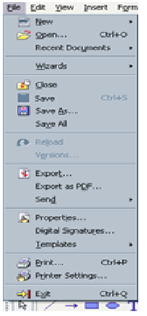 | New  Used to create a new presentation.  Open  Used to open an existing file from a floppy disk or hard drive of your computer.  Close  Used to close a presentation.  Save  Used to save a file that you have changed. If you close the presentation without saving it, the changes you made will be lost.  Save As  Used to save a new file for the first time or save the existing file with a different name.  Print  Used to print the presentation.  Exit  Used to exit Impress or any other application in the OpenOffice.org software suite.

Opening an Existing Presentation Using the File Menu

You can open any presentation that has been named and previously saved from the File Menu or with the Wizard.

To open an existing presentation:
- Click the Open existing presentation button. 
The Open dialogue box opens.
- In the Look-in list, click the drive, folder, or Internet address where the file that you want to open is located.
- In the folder list, open the folder that contains the file, and then click in the file you want to open.

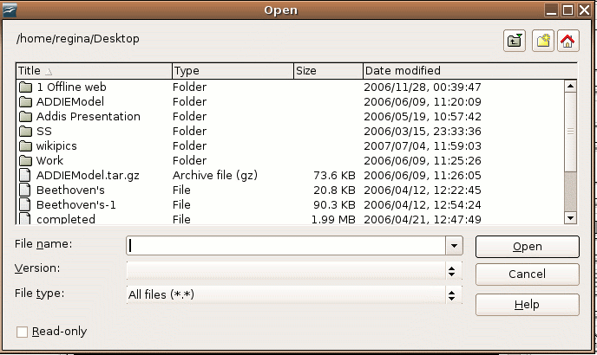

- Click the Open button. The presentation will open.

Opening more than one Presentation

You can open more than one presentation. Without closing one, just follow the same instructions and open another presentation. You now have two presentations on your desktop, the one on top of the other one.

You can switch between the two open presentations:

- If your presentations are not maximised (you can see part of the second presentation), you can click on the one that you want to work on. It will move to the front and you can work on it. If you want to work on the one behind, just click anywhere on the presentation and it will move to the front. The active one’s title bar will be in the default colour and the other one will be grey.

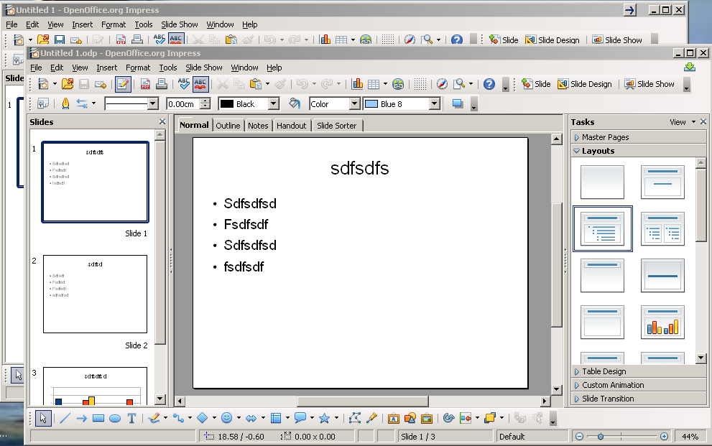
- If the presentations are maximised, you can work on one, minimise it, and work on the back one. To maximise it again, pick it up from the bottom of your screen.

Saving a Presentation

You must assign a distinguishable name to every presentation that you create in Impress. If you don’t name the file, you won’t be able to open and update it in the future.

The first time you save a presentation, Impress will prompt you to assign a name through the Save As operation. You must then identify the location (folder and sub-folder) on the drive (A:, C:, D: etc) you want to save it to.

You can make additional changes to a file – add a slide, change text, add a picture, etc. – and then only use the Save option. The presentation will be saved to the original location and file name, thus overwriting the previous saved version.

To save a new Impress presentation:

- Choose File Save As from the menu bar.
- The Save As dialog box appears.

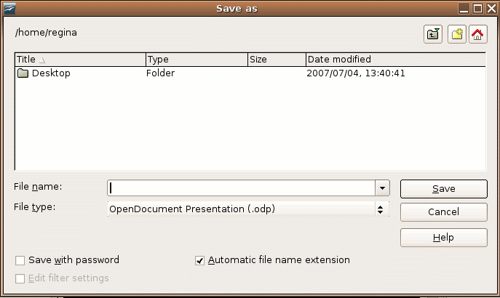

- Click on the Save In: drop-down menu and locate where you want to save the file.

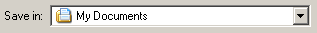
Choose:
  - 3 ½ Floppy (A:) to save the file to a floppy disk;
  - Local Disk (C:) to save the file to your hard disk; or
  - D: onwards means any other device you have installed to save in. It can be a network, flash memory stick or an external hard drive. Check the description.
- Type a name for your file in the File name: box.
- Click the Save button.

To save changes that you’ve made to an existing presentation:

- Choose File Save from the menu bar, or
- Click the Save button on the Standard toolbar (third button from left on top row).

Tip: It is a good idea to save your work frequently when working in Impress so that you do not lose information!

You can quickly save your presentation by using the quick-key combination: Ctrl + s.
To save changes that you’ve made to another presentation/under a different name:

- Choose File Save As from the menu bar.
- You can now do one of the following:
  - Choose an existing presentation that you want to overwrite. Click on the presentation name and hit Save.
  - Type in a new file name to save the current presentation with the changes to a new name and hit Save.
  - Change the folder of the file, by copying the existing presentation to a new folder under the same or different name and hit Save.

Saving a Presentation in Different Formats

If you look at the FileSave As dropdown menu, you will see that there are several formats that you can save a presentation in. These are:

- ODF Presentation (.odp) – a normal presentation that you can edit in Impress
- ODF Presentation Template (.otp) that you can save as another file, edit and reuse
- various other versions of OpenOffice – both as presentations and templates
- various other versions of office applications such as MS Word, StarDraw – both as presentations and templates
- drawing object (image file format) – (odg)

Check the options that are given in the Save as type dropdown menu.
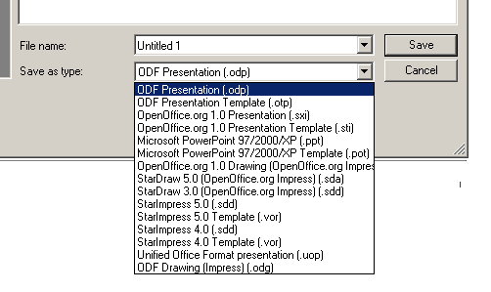

Export a Presentation in Different Formats (.pdf and .swf)

If you want to save the file in another format than what is available in the dropdown menu, you have to export the file to another format.

To execute choose FileExport. You have several choices, but the following two are useful to save as:
  - Portable Document Format (.pdf) gives you the ability to print and send a file in its final form.
  - Macromedia Flash file (.swf) gives you the ability to view the presentation as a Flash show. Just remember you have to download the Adobe Flash Reader for reading this file.

Saving a Presentation in Rich Text Format

To save as Rich Text Format, you must copy and paste the content of your slides from the Outline View into Writer and use the Save As function in Writer to save as Rich Text Format.

Rich Text formatted files are often called RTF files. RTF files can be opened and used with any word processor, including OpenOffice, WordPad, NotePad, Word, and Star Office. An OpenOffice file can be saved in RTF through Writer. The RTF format can be a good way for OpenOffice to exchange text files with users of other operating systems such as Microsoft Word.

Saving a Presentation in Different Versions

To save a file as another version, press FileVersions. Click on the Save New Version button. You will be given the option to insert a version comment e.g. Ver1.0. Press OK. The versions already saved will be reflected in the look-in list. Press Close.

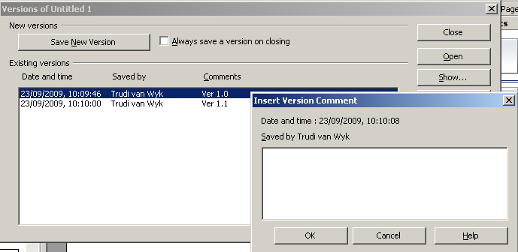

If you have saved several versions and you want to access them, you can press FileVersions. In the look-in list, highlight the version you want to open and press Open. Through the same procedure you can also delete a version by pressing Delete. After you have completed the action, you press Close.

Closing an Impress Presentation

To close an existing presentation chooses FileClose from the menu bar. The presentation in the Impress window closes.

Alternatively – just click on the Close button to close the program.

Impress prompts you to save your work if you have made any changes to the presentation between the last save and the time the file is closed.

Exiting Impress

To exit Impress choose FileExit from the menu bar.

Slide Navigation – Moving Around the Presentation

You can move around the presentation in several different ways. You will need to know how to do this in order for you to navigate through your slides and presentation.

Scroll Through a Slide Using Scroll Bars

To move up and down in a presentation slide in the Workspace, particularly when working with magnification, use the vertical scroll bar located along the right edge of the Workspace. To move left or right, use the horizontal scroll bar, located at the bottom of the Workspace.

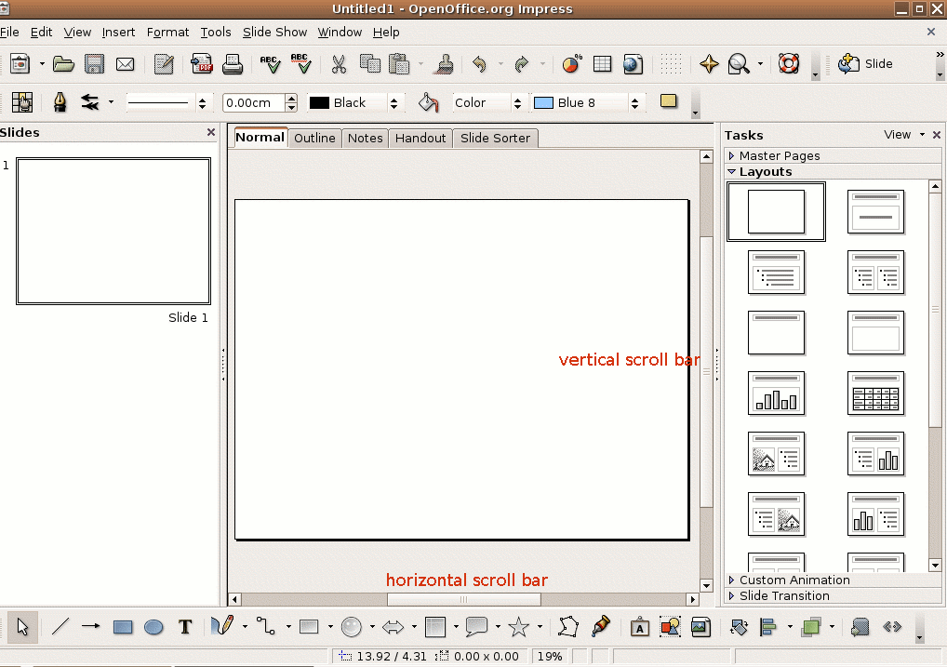

Scroll Through the Presentation

- In the Workspace, use the Page Up and Page Down keys on the keyboard to move up or down through the presentation, one slide at a time.
- Alternatively you could also click and scroll on the mouse to navigate through the presentation.
- You can also use the Home key to display the first slide in the presentation, or the End key to display the last slide in the presentation.
- You can also use the slides pane to move up and down through a presentation. There is also a scroll bar on the slides pane to scroll through the presentation. This scroll bar is only visible if you have created a lot of slides.

Enhance Productivity

Set User Preferences in the Application: User Name, Default Folder to Open and Save the Files

Sometimes the user wants to set up certain default settings for all his/her presentations. These can include, but are not limited to:

- User Data e.g. user name, contact details
- default folder/path to open and save the documents

To change the User Data:

- Choose ToolsOptions.
- Click on User Data in the left block and complete the fields in the right block.
- Press OK.

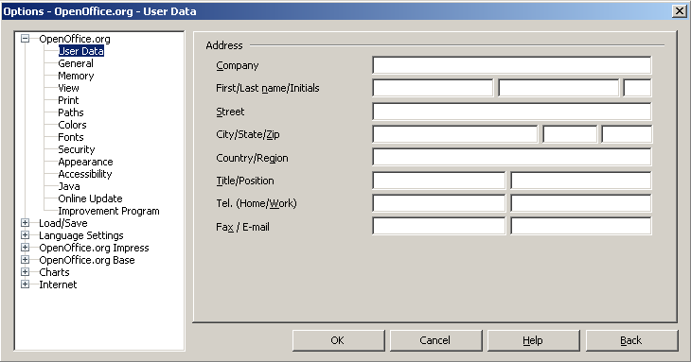

To change the default folder/path to open and save the documents:
- Choose ToolsOptions.
- Click on Paths in the left block
- Highlight My Documents in the right block.
- Click on Edit.
- Select the folder you want to use as default folder.
- Press OK and OK.

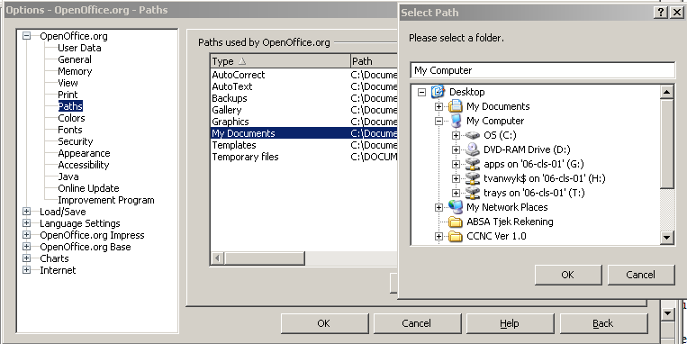

Use Magnification/Zoom Tools

There is sometimes a need to change the size of the document that you are viewing/working on, for example to see more detail or to be more readable. This will however not change the printing output of the document.

- The first way to change the size of a presentation on screen is to use the maximise, minimise and tile functionalities. Use the buttons on the top right of your screen.
- The second is to use the zoom function. Just remember that zooming is handled differently on Unix, Linux, and Windows platforms. A document saved with a 100% zoom factor in Windows is displayed at a larger zoom factor on Unix/Linux platforms. To change the zoom factor:
  - double-click or right-click the percentage value on the Status bar, and select the zoom factor that you want; or
  - Click on the zoom button and select from the dropdown menu 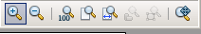, or
  - Choose ViewZoom and choose the appropriate radio button and press OK.
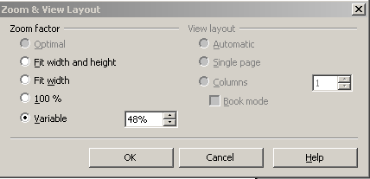

How to Use the Help Function

As you know by now, you can use the Help Menu to get help.

Choose HelpOpenOffice.org Help F1

or

Press <F1>

The look-in list located at the very top is where you can select other OpenOffice.org Help modules such as Writer, Calc and Draw (other OpenOffice applications).

You can also get access to the Navigation Pane that gives you an option to choose one of the following tabs:

The Index and Find tab pages only contain the data for Impress, while the Contents tab gives you data on the whole OpenOffice.org.

The different tabs can be used as follows:

The Contents tab displays an index of the main topics of all modules.

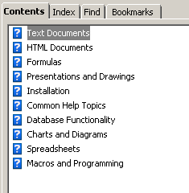

The Index tab displays a list of index keywords for Impress. By typing in the first letter of a word, you can get help displayed on that specific topic.

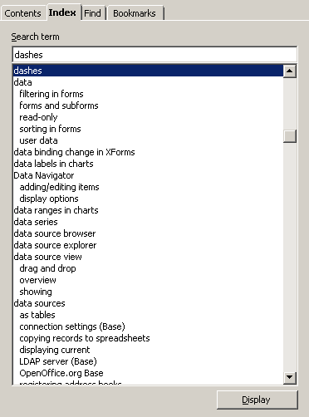

- The Find tab gives you access to a full-text search. The search will include the entire Help contents. You can only type the word/term you need help on and hit Find. Refine your search by choosing from the list displayed and hit Display.

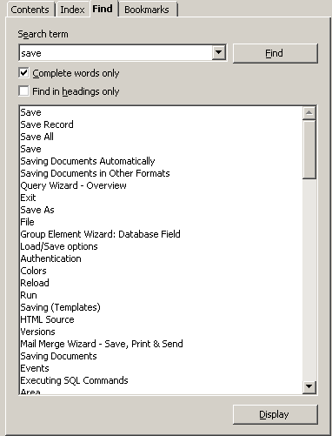

The Bookmarks tab will contain bookmarks that you have defined. You can edit or delete bookmarks, or click them to go to the corresponding pages.

Summary

In this section you were introduced to the overall look and feel of the Impress Window layout and how to work with presentations.

By now you would have an understanding of the Impress Window layout and acquired the knowledge on how to:
- save a presentation and exit Impress
- navigate through slides
- set up user preferences in the application
- use the magnifying tools/zoom
- use the help function

Developing a Presentation

Section Overview

In this section you will be able to develop a presentation, use different presentation views, choose different slide layouts and designs.

By the end of this section you will be able to:

- create a presentation using templates
- create new presentations
- insert, duplicate and delete slides
- use presentation views to develop and edit your presentation
- develop slides using different layouts and designs for your presentation

Creating a New Presentation

Practice makes perfect is the only way to master a presentation. The following sections will enable you to perform the tasks.

Using Pre-defined Presentation Templates

Using Pre-defined Presentation Templates in Your Presentation

Impress comes with two pre-defined presentations that you can copy and use for your own presentation. Each presentation is formatted and contains pre-written content.

You can select the presentation templates whenever you create a new presentation from a template using the Wizard. You have two options:
- “Introducing a New Product”; or
- “Recommendation of a Strategy”.

Compare the content below:
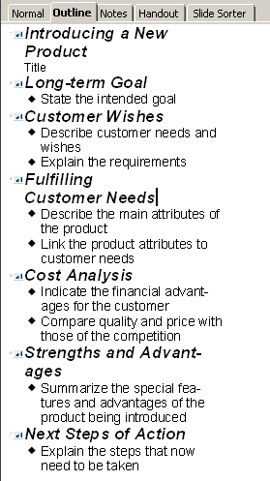
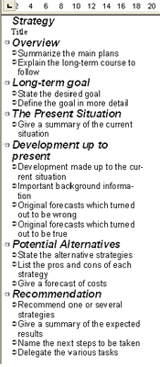

Remember that you can also change your presentation from the design and content of the template.

Impress is also equipped with different presentation backgrounds that you can use in your presentation. You can select these presentation backgrounds whenever you create a new empty presentation using the Wizard. Once you make a selection, Impress then displays the available templates for the selected option. If you select one, you will create a similar presentation to the one you see in the thumbnail on the right hand side of your screen.

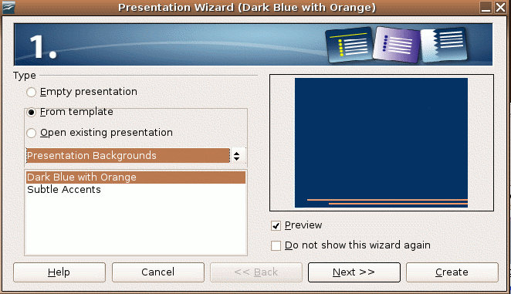

Creating a Full Presentation from a Template

You are now going to use the Wizard to create a new presentation based on the full existing presentation template of “Recommendation of a Strategy”.

To create a new presentation based on the pre-designed template:

- Choose FileNewPresentation from the menu bar.
- On the Wizard Presentation dialogue box, click on the From Template button.
- Choose Presentations.
- Choose Recommendation of a Strategy.

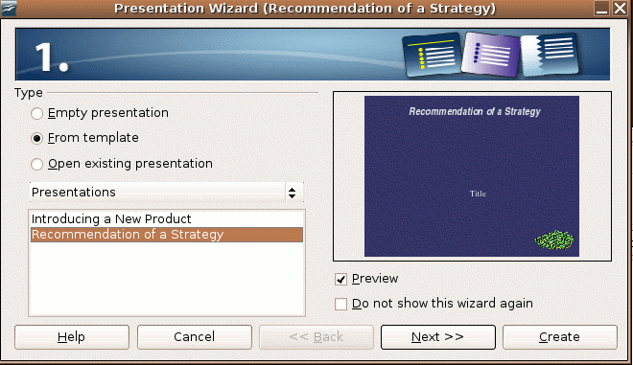

- Click the Next>> button to display the second screen of the Wizard.

In this screen you can select the slide design.

- Select the presentation background to be used in your presentation (check the design in the thumbnail on the right).

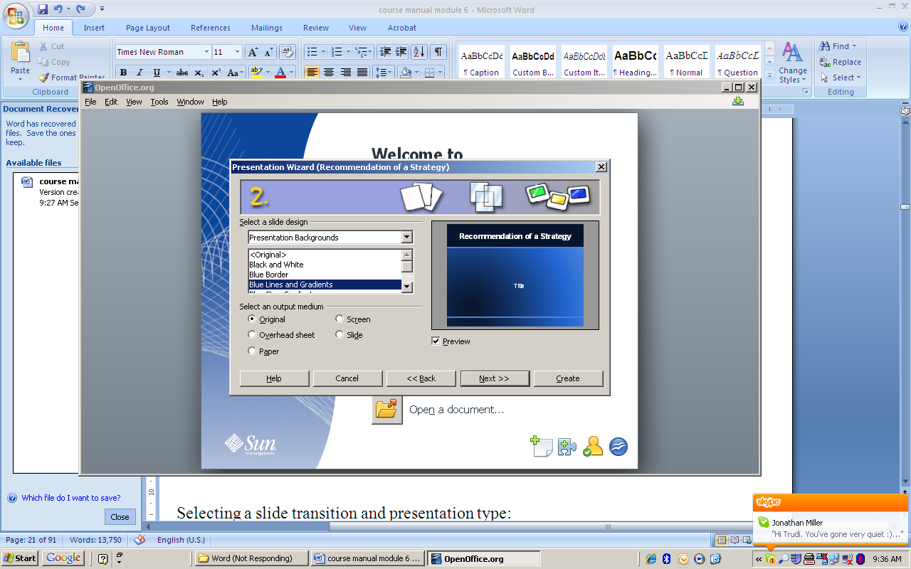
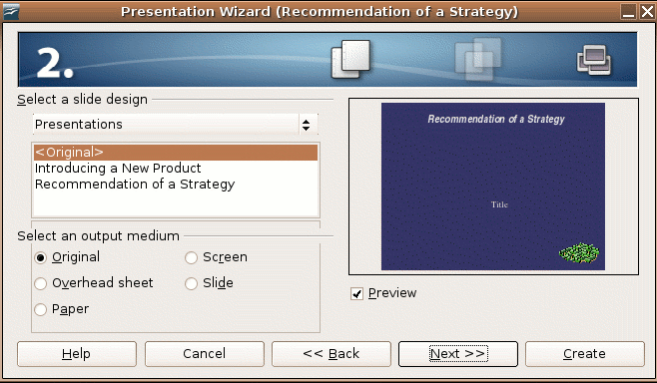

- Click the Next>> button to display the third screen of the wizard.

In the third screen you can select a slide transition of your slides:
- Effect – How one slide will change to the following one; and
- Speed – The speed between the transitions (slow/medium/fast).

You can also select the presentation type:
- Default – You can present your slides by clicking the mouse or press the Page Down or →/↓ arrows; or
- Automatic – Your presentation runs automatically and you can set the time you can view a slide and the time to move over to a next slide.

You can also decide if you want to show the logo on each page by marking the appropriate block.

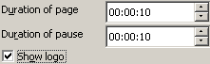
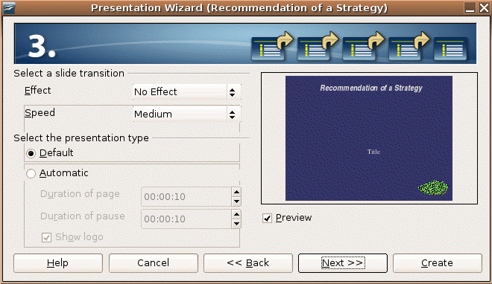

In order to make these choices:

- Under Select a Slide Transition, click in the drop-down area to select any of the 57 available effect transitions. The right hand area of the screen provides an example of each effect as you scroll through the available choices.
- Under Select a Slide Transition, click in the drop-down area to select the Speed of the slide transition (Slow, Medium, or Fast).
- Under Select the presentation type, select either Default or Automatic to define whether the presenter will manually advance slides in the presentation (default), or whether the slides will automatically advance based on Duration of page and Duration of pause timing definitions.
- Click the Next>> button to display the fourth screen of the wizard.

In the fourth screen you will provide basic information on the presentation you are developing.

Type information in each of the three questions displayed on the screen:

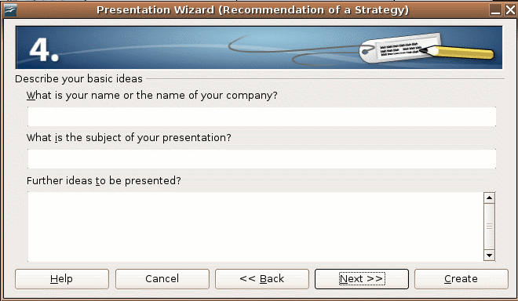

Click the Next>> button to display the fifth screen of the wizard.

In the fifth screen, you have to choose your topics or pages.

The presentation comes with seven pre-written slides. Remember, on page 26 we explained that the template has pre-written content under seven headings. These slides/pages are the same as the content displayed on page 26. Please check carefully that you understand where this is coming from.

Here you have the choice to remove/include the content displayed in the template. All slides that contain a checkmark in the Choose your pages area will be included in the new presentation. Uncheck any slides that you do not want to include in the presentation.

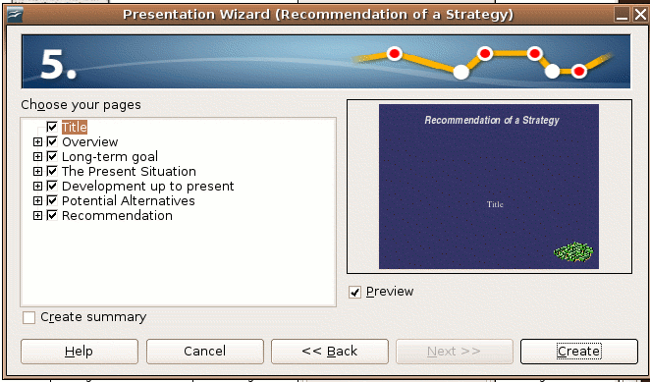

Click the Create button to create the presentation and display the first slide.

It is advised that at this stage you save your document under a new name. Please be careful in deciding in which folder you save your document. You must be able to retrieve your document again.

You are now ready to popularise your presentation using the template.
You can enter text in all the slides.

Creating a Presentation from Scratch

It is not always convenient to use a template if you have to make too many changes. It is sometimes better to create a presentation from scratch. If you want to create a presentation from scratch, you start the same way as on page 27.

When you want to do this, first plan your presentation. Write on a piece of paper what you want to put on each slide. Use the information from the first section of this module. If you are satisfied with your plan, you can start.

- Choose FileNewPresentation from the menu bar.
- On the Wizard Presentation dialogue box, click on the Empty presentation radio button.

Go through the rest of the screens 2 – 5 as above. On screen 5 you will see that you cannot choose Next>>, choose Create.

You will be able to start your presentation from scratch now.

Slide Backgrounds

In the first section you have been introduced to the importance of choosing the right colour and design for a background. Impress has several backgrounds that you can choose from.

Some examples are:









Play around with different backgrounds and see for yourself what effect different backgrounds have on a presentation.

You can also just choose a background colour without any design for your presentations.

On any slide of the presentation, choose FormatPage.
Click on the Background tab to access the drop-down menu. Choose color, and make your choice of colour.

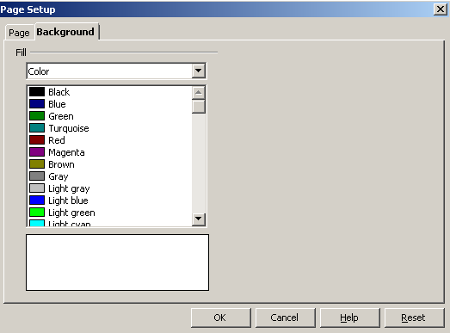

You will be asked:

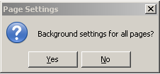
If you select yes, all the slides will have the chosen colour background. If you select no, only the one slide that you are working on will have the background colour.

By doing the same you can change the background colour to have different appearances e.g.

Gradient effect | 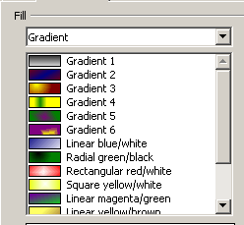 | 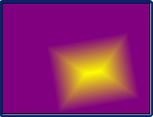
Hatching effect | 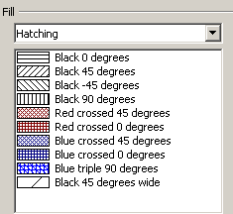 | 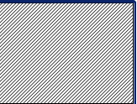
Bitmap | 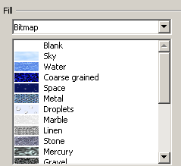 | 

To summarise, if you want to use a bitmap, colour, gradient or hatching pattern for the slide background:

- Start a new presentation or open an existing one.
- Click FormatPage on the menu bar.
- Click on the Background tab on the Page Setup dialogue box.
- In the Fill area, do one of the following:
  - Select Color, and then click a colour in the list.
  - Select Gradient, and then click a gradient style in the list.
  - Select Hatching, and then click a hatching style in the list.
  - Select Bitmap, and then click a bitmap style in the list.
- Click the OK button.
- Click either the Yes or No buttons in the Page Settings dialogue box to answer the question to change the “Background settings for all pages”.

Slide Layouts

Impress allows you to select from many different Layout slide templates to use in your presentation. Impress prompts you to assign a layout each time you add a new slide. You can change the layout assigned to any slide in the presentation at any time.
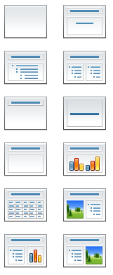
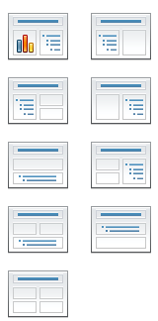

The type of slide layout you should use depends on what you want to include into your presentation, whether it is to add only text or add text, graphics and charts.

To apply a layout to an existing slide:

- Click on an existing slide without text in the slide pane to activate it in the Workspace.
- Ensure that the Layout menu is active on the right-hand side of the screen by either clicking on the Layouts bar or choosing FormatSlide Layout from the menu bar. On the right a variety of thumbnail layout slides will appear.
- Click on the appropriate layout slide (thumbnail) to apply that layout to your slide.

Once you have clicked on the thumbnail it will apply that layout to your current slide.

Adding, Copying and Deleting Slides

Inserting Slides

Each Impress presentation that you create will begin with a single slide. After you change the opening slide, you’ll want to add more slides to your presentation. The number of slides that you add to the presentation is dependent on the length of your presentation.

To insert a new slide in a presentation you can do one of four actions:

- Choose InsertSlide from the menu bar. A new slide will be added after the active slide on your Workspace. The slide will have the same layout as the slide on your workspace.

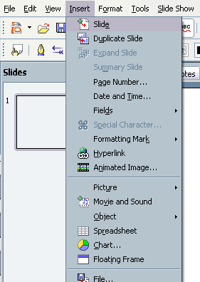
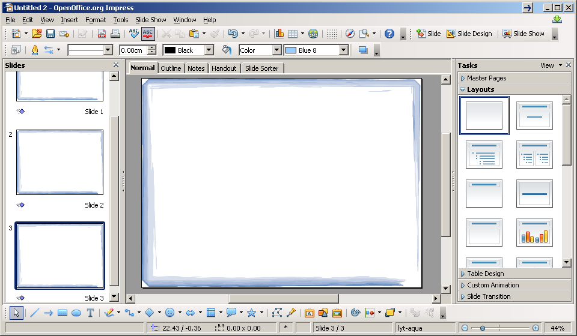
- You can also hit the button on the tool bar. A new slide will be added after the active slide on your Workspace. The slide will have the same layout as the slide on your workspace.
- Another way to insert a slide is to go to the slide pane, click on a slide to activate it in your workspace, right-click and select SlideNew Slide from the menu. A new slide will be added after the one that you have first clicked on. The slide will have the same layout as that slide on your Workspace.
- You can also go to the position for the new slide on the slide pane (between two slides), right click and hit new slide. The new slide will have the same format as the previous one.

After you have inserted the slide, you can change the layout by clicking on any of the 20 different Layout thumbnail images in the Task pane to apply that design to the new slide.

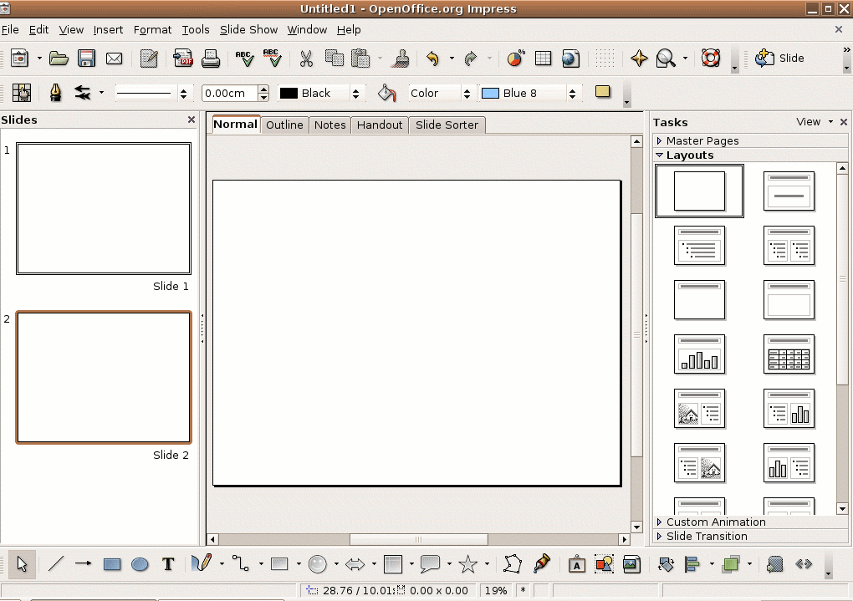

Duplicating Slides

Duplicating or copying a slide is another technique that you may use as you work on your slide presentation. For example, you may want to repeat a slide later in the presentation or copy a slide and make small changes to it to make a different point. When you duplicate a slide, you make an exact copy of it.

To duplicate a slide in the presentation:

- Navigate to the slide that you would like to duplicate, either by paging through the presentation in the Workspace or by selecting the slide on the Slide Pane.
- Choose InsertDuplicate Slide from the menu bar.

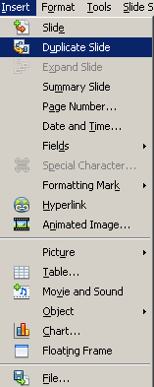

- A new slide, an exact duplicate of the original slide, will appear at the bottom of the original slide and will be displayed on the screen.

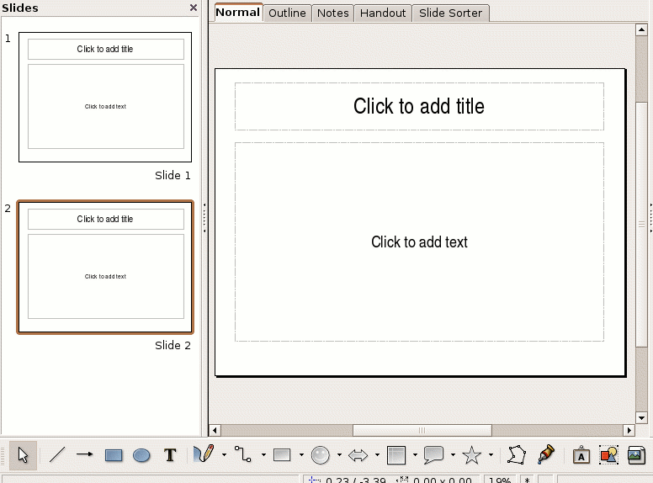

You can now move the slide to another position by dragging it on the slide bar.

To duplicate a slide in the presentation, you can also copy and paste it to the position you want it to appear:

- Navigate to the slide that you would like to duplicate, either by paging through the presentation in the Workspace or by selecting the slide on the slide pane.
- Click on the slide on the slide pane so that it is highlighted.
- Do one of the following:
  - Choose EditCopy from the menu bar
  - Right-click and choose copy
  - Press on the tool bar
  - Press Ctrl+c
- Move to the desired location for the slide to appear on the slide pane and paste it by:
  - Choosing EditPaste from the menu bar
  - Right-click and choose paste
  - Press on the tool bar
  - Press Ctrl+v
A new slide, an exact duplicate of the copied slide, will appear at the pasted location and will be displayed on the screen.

You can use the same procedure to copy slides from one open presentation to another.

Follow the following steps:

- Ensure that both presentations are open on your desktop.
- Follow steps 1 – 3 on the presentation that you want to copy from.
- Activate the second presentation (see page 16).
- Follow step 4 above.

Deleting Slides

Sometimes you may want to take one or more slides out of your presentation. With Impress, you can delete any slide from a presentation, even if it has text or a picture on it.

To delete a slide from the presentation:

- Navigate to the slide that you want to delete from the presentation, either by paging through the presentation or by selecting the slide on the slide pane.
- Do one of the following:
  - Choose EditDelete Slide from the menu bar
  - Press the delete key
  - Right click and choose Delete Slide from the shortcut menu
  - Press Ctrl+x

If a dialog box appears (if the slide you are deleting contains information on it and you have used the first option), click the Yes button to remove the slide and all the data on it.

Creating and Applying Presentation Views

(Refer to the Page View Buttons on page 14)

Various presentation views can be displayed in Impress. It is important to know that these views were created to maximise the productivity of the person who is using the program.

You must be able to:

- use different Workspace views
- apply a Textbox (text in a Title and/or Text Placeholder ) to a slide
- add text in Outline view
- create a Master view

Slides Workspace View

As you work through your presentation, you may find it helpful to view only the thumbnails of your slides at the same time (such as it is displayed in the slides pane). This allows you to view the entire presentation in the Workspace instead of a single-slide in the Workspace as in the past. To identify the difference we say we want to change the Drawing Workspace to a Slide Workspace View.

The Slide Workspace View displays miniature versions of the slides. In this view, you can quickly scan through the order of the presentation and rearrange the order of your slides in the presentation, add or change transitions and hide slides.

To Switch to Slide Workspace View, choose ViewSlides Sorter from the menu bar.

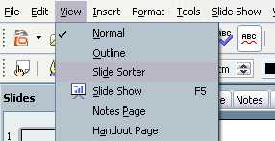

You can also click on the Slide Sorter button/tab at the top of the Workspace.

The Impress screen displays the slide and its content in the selected view.

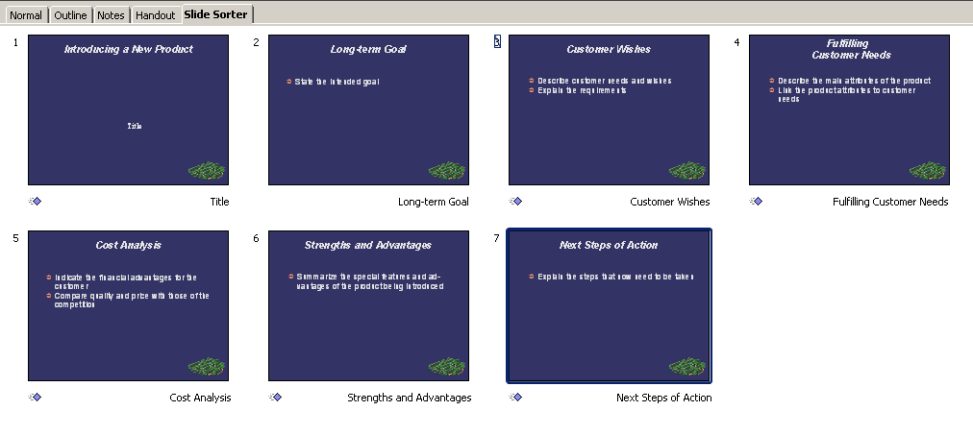
Note:

- The icons at the bottom of the slide indicate the transition of the slides.
- Slide 2 has no transition, the transition has been removed.
- If a slide is hidden, a will appear over the slide number.
- Slide 3 is hidden and will not show in a slide show.

Notes View

Just because you created a presentation does not mean that you will remember all of the details or points that you would like to make throughout your presentation. People get nervous. People forget. Impress provides a Notes View that allows you to define custom-written notes for any slide in the presentation. Visually, this view provides an image of the slide at the top of the page and allows you to input notes at the bottom of the screen.

To switch to the Notes Workspace View choose ViewNotes Page.

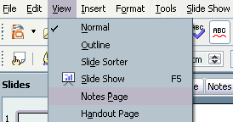

You can also click on the Notes button/tab at the top of the Workspace.

The Impress screen displays the slide and its content in the selected view.

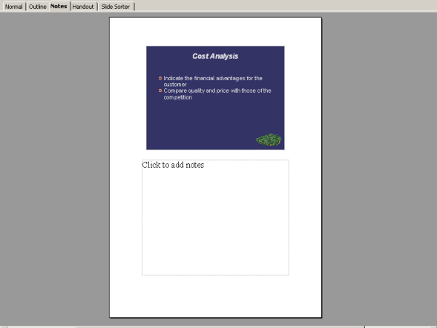
You can now add your notes in the space below the slide. It will not display on your slide show, but can be printed out for the speaker. It is important to use this space for acknowledgement of copied work.

Handout View

Presenters frequently want to provide printed handouts to members of their audience. The Handout View provides a visual of the presentation on printed pages.

To switch to the Handout View, choose ViewHandout Page from the menu bar.

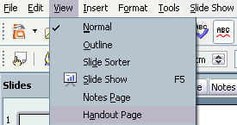

The Impress screen displays the page layout of the slides on handout pages.

Creating a Master for your Presentation

If you work for a company, you may be asked to prepare presentations using a photo as background and use some formatting that is not exactly what the Layout menu provides. Or, you have to include the logo of the company on each page. In order to prevent you from changing each page of the presentation, and repeatedly copy the same logo to each page, you can create a Master to automate that for you.

Just remember, with every photo, logo or graphic you add to a page on your presentation, you add to the size of the file. It makes a file very big. By doing it in the Master, you only use the photo, logo or graphic once, and it results in a much smaller size file.

The Master View allows you to create a presentation with different types of slides but enable them to all have the same “look”. The elements that you add to the Master View – such as a company logo, background and font colour – will be applied to all of your slides.

It is important to popularise the Master View of a presentation before you start working on the presentation. It is like setting the table for a great meal to follow.

How a presentation is presented depends on how the Master was initially created. Empty presentations generate a Master View with a plain, white background.

You can change slide and notes with the Master.

Creating a Master for a Presentation

Follow the following stages and steps. Each stage will demonstrate a certain feature of the Master.

- Create an empty presentation (FileNewPresentation. Choose: Empty Presentation and hit Create).
- Choose: ViewMaster and start with the Slide Master.

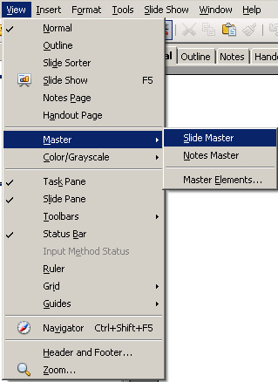

The slide master consists of only one slide. All the Layout templates will work on top of the settings you put in the Master.

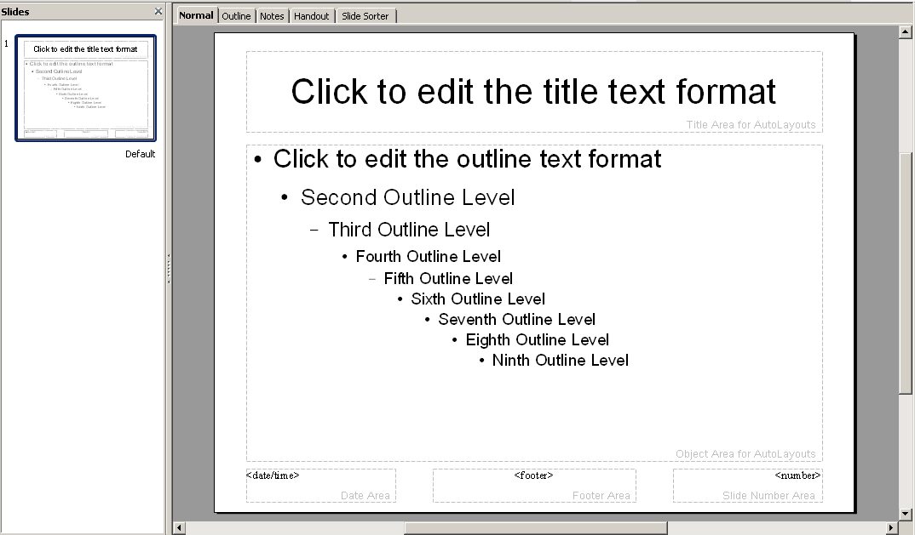

You see a slide with a white background, a certain text format (e.g. in this case Arial), different level bullet outlines (bullet outlines), place holders for <date/time>, <footer> and <number>.

Background Design

To change the background design of all your slides to the same design in the Master:

- Click on Master Pages Bar in the Task Pane. It will expand the Master Pages menu. Click on the design you want to use. Note that the format of the text on the master slide has changed with the layout.

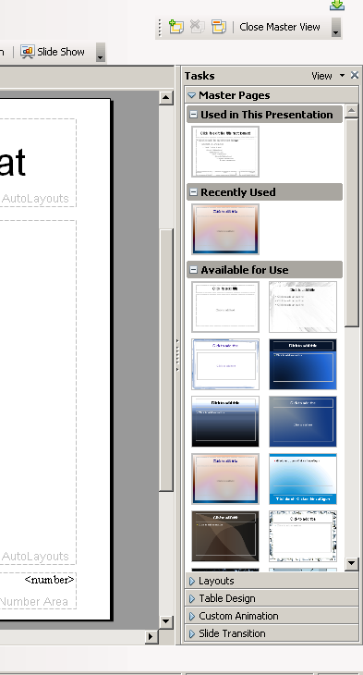

If you created a new presentation with a coloured background or from a template, the Master Slide of that presentation will also display those unique style definitions and/or colour scheme.

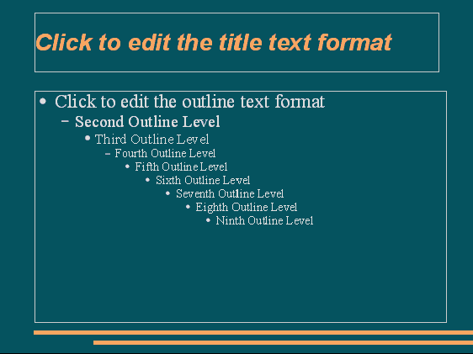

Background Fills

The default background fill for empty presentations is a plain, white colour in Impress. You can choose to retain this background in the Master or change it to a different colour, gradient, hatching, or image (see page 32).

The background fill is defined on the Page Setup dialogue box.

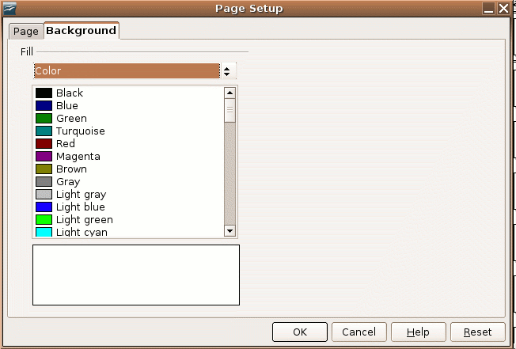

Regardless of the background fill category you select (colour, gradient, hatching, or image) Impress gives you many choices in each category.

Remember, if you apply a background fill to a single slide, it overrides the master page background. However, objects on the master page remain visible.

Text Elements

After changing the design and background colour, the Workspace will reflect the font type, colour, size and enhancement of each level of bullet you would use in your slide.

You can change the attributes of the font on the Master and it will reflect in all your slides. Just remember to be cognisant of the design principles discussed at the beginning of this module.

As you continue working on your Master View, notice that the Master text-styles placeholder contains a model of up to nine bullets. The text becomes smaller for each bulleted level. Font sizes are pre-selected in the Master View. The sizes are based on what a normal person is able to read from a reasonable distance. You can change the font size, but this is fine-tuning that you might want to do later. Generally, the text should remain the same colour for the title and all text levels.

To Edit the Text Styles on the Master View you can:
- Select to highlight the text (title text or body text) that is subject to formatting change.
- Format the selected text by changing its font, size, appearance (bold, italic, underline), and alignment using the Formatting Toolbar.
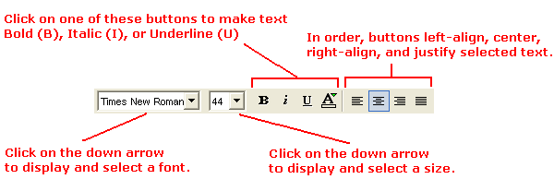

Place Holders/Areas for <date/time>, <footer> and <number>

At the bottom of the Master slide you will see three placeholders for <date/time>, <footer> and <number> (default on the Master).
You can decide if you want to make use of these.

- To change them you can click on the frame of the placeholder 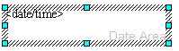and format the block (alignment, font) or add some words.
- You can type in the footer placeholder what must appear on each slide of the presentation.
- To delete the placeholder, choose ViewMasterMaster Elements and select/deselect what you want to appear on the Master. Hit OK when you are finished.
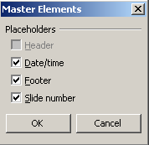

Remember, if you want the date and time to be reflected as the current date (update the fields automatically), you would use the above format for date and time. However, if you want the date and time to be fixed, delete the <date/time> in the placeholder and type the date or time in. Now the date and time will not be updated.

Adding a Footer to All Slides

Another way you can add a Footer as a text object on the Master page in your presentation is as follows:

To add a Footer to all your slides:

- Click ViewHeader and Footer on the menu bar
- Select the Slide tab.
- Type in/tick the various text/tick boxes.
- Press Apply to All tab to save changes.

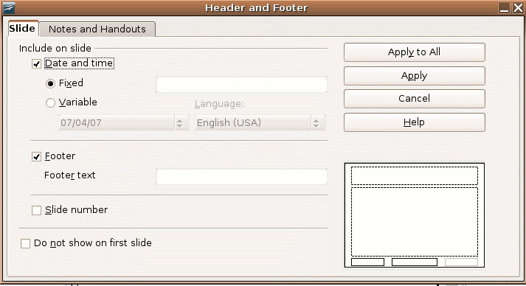

Adding a Graphic or Object

You can add a picture, image or object that has been saved in a folder on the Master page in your presentation in the following way:

To insert a picture or image in a file to all your slides:

- Click InsertPictureFrom File on the menu bar.
- Browse through your files to find the picture.
- Click on the filename to highlight it.
- Hit Open

You can resize and move the picture to the desired location on your Master. The graphic will appear on each slide.

You can also copy a picture or image from another open presentation/file and paste it into your Master (see page 16).

To insert an object such as a Spreadsheet or Chart to all your slides:

- Click InsertObjectOLE Object
- Choose if you want to create a new one or use one from an existing file.
- Identify the object type/search for the appropriate file.
- Hit OK.

You can resize and move the object to the desired location on your Master. The graphic will appear on each slide.

Removing a Graphic or Object

You can remove a picture, image or object that has been inserted in your presentation by clicking/highlighting the object and hitting the Delete button.

Changing the Master for Notes and Handouts

By following the same logic as above, you can change the Master for Notes Pages and Handouts.

In summary:

- to view – Choose ViewMasterNotes Master

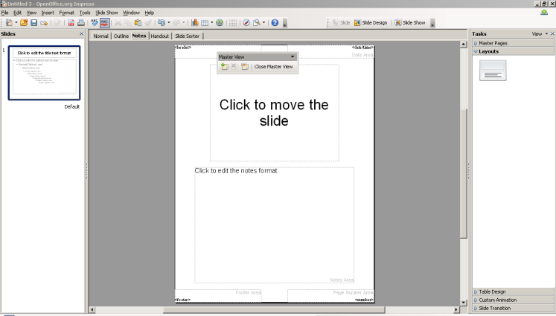

- you can edit the Header Area, Date Area, Footer Area and Page Number Area by:
  - Move them around (click and drag)
  - Change the appearance (fonts, alignment and size)
  - Add content
  - Delete content
- you can change the master elements (existence of the Header, Date/time, Footer and Place numbers
- add headers and footer to all your slides by:
  - Click ViewHeader and Footer on the menu bar
  - Select the Notes and Handouts tab
  - Type in/tick the various text/tick boxes
  - Press Apply to All tab to save changes

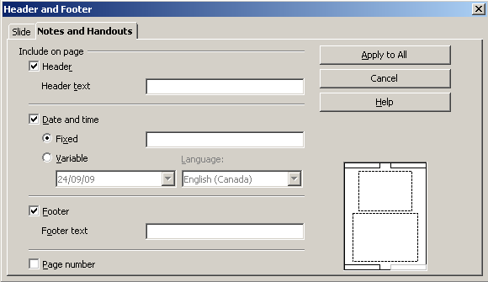

Viewing the Master View Elements

After creating or making changes to your Master, you can view all of the basic design elements in the Workspace of your Master View.

Close Master View

To close the Master View, press the Close Master View button on the floating Master View Toolbar.
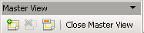

Summary

In this section you have learnt how to develop a presentation, use different presentation views and to choose different slide layouts and designs.

You must now be confidently able to:

- create a presentation using templates
- create new presentations
- insert, duplicate and delete slides
- use presentation views to develop and edit your presentation
- develop slides using different layouts and designs for your presentation

Adding Text to Slides

Section Overview

In this section you will handle and format text and work with lists and tables in your presentation.

By the end of this section you will be able to:

- use standard and outline view to enter text
- edit, copy, move, delete text within and between presentations
- use the undo, redo command
- apply and change formatting of text
- edit bullet and number lists
- create, populate and format a table slide

Handling Text

Pre-Knowledge – Good Practice

Please read the first section of this module again. Make a summary of good practice relating to text and the way to plan for a presentation.

Enter Text into Placeholders

An unedited slide created by the AutoLayout contains different text placeholders, e.g.:

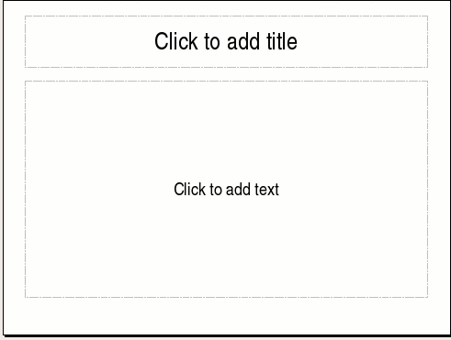

All placeholders were formatted in the Master as done in the previous section.

Title Placeholder

In your planning of the presentation you will have a series of titles for your slides. You will enter them in the Title placeholder on the top of each slide.

The Title placeholder is marked by the default text, “Click to add title”. To add text to the Title placeholder, simply click on the text, the words will disappear and type the relevant title.

Remember to keep it short and descriptive. Use the word wrapping feature if the title is longer than one line (do not press enter at the end of each line).

Text Placeholder

The text placeholder is marked by the default text, “Click to add text”.
To add text to the text placeholder, simply click on the default text and type the relevant text. It will be formatted according to the design format and layout you have chosen.

Adding Text in Outline View

Outline view is very effective when you want to check the flow of your slides and edit text. In the Outline view, the slide is displayed in text form.

To be most effective, it must be used in conjunction with the Slides pane as shown on the following screen so that you can see what the finished slide will look like.

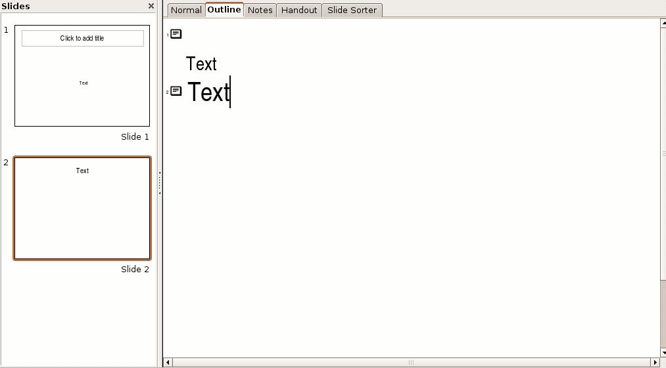

Adding a Textbox to a Slide

- To Add a textbox to a slide, click on the Text icon on the drawing toolbar (as shown below)

- Position it where you want to place the text and click. A narrow textbox is displayed.
- Start typing the words into the text box.

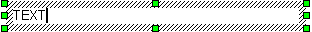

You do not need to worry about the size of the text box. It will expand downwards to accommodate the text as you type. You can manually resize it or change the font size and format of the text later if you wish.

Tip: Move the text box by holding the mouse over one of the perimeters of the text box until the crossed arrows appear. Hold down the left mouse button and drag the text box to another position.


Copy, Move and Delete Text and Text Boxes

Text boxes as discussed above can be copied, move and deleted. This means that the whole text box, with its content and format will be copied, moved or deleted.

To copy a text box:

Hold the mouse over one of the perimeters of the text box until the crossed arrows appear (see the above tip). Click. The appearance of the text box will change and display handles (little blocks on the perimeter).

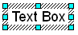

- Do one of the following:
  - Choose EditCopy from the menu bar.
  - Right-click and choose copy.
  - Press on the tool bar.
  - Press Ctrl+c.

- Move to the desired location for the text box to appear. It can be:
  - on the same slide
  - on another slide in the same presentation
  - on a slide in another presentation

- Choose one of the following:
  - Choose EditPaste from the menu bar.
  - Right-click and choose paste.
  - Press on the tool bar.
  - Press Ctrl+v.

To move a text box:

- Hold the mouse over one of the perimeters of the text box until the crossed arrows appear (see the above tip). Click. The appearance of the text box will change and display handles (little blocks on the perimeter).

- Hold down the left mouse button and drag the text box to another position.

The above way is quite limiting. You can also cut it and paste it at another location.

- Do one of the following:
  - Choose EditCut from the menu bar
  - Right-click and choose cut
  - Press on the tool bar
  - Press Ctrl+x

- Move to the desired location for the text box to appear. It can be:
  - on the same slide
  - on another slide in the same presentation
  - on a slide in another presentation

- Choose one of the following:
  - Choose EditPaste from the menu bar
  - Right-click and choose paste
  - Press on the tool bar
  - Press Ctrl+v

To delete a text box:

Hold the mouse over one of the perimeters of the text box until the crossed arrows appear (see the above tip). Click. The appearance of the text box will change and display handles (little blocks on the perimeter).

Press the delete key on your keyboard.

To copy, move and delete text in a Text box, without changing the text box, you can do similar actions. The only difference is that you do not select the whole text box, but only the text within a text box.

To copy text:

Highlight the text you want to copy by using your mouse.



Note that there is no change in the perimeter of the text box.

- Do one of the following:
  - Choose EditCopy from the menu bar
  - Right-click and choose copy
  - Press on the tool bar
  - Press Ctrl+c

- Move to the desired location for the text box to appear. It can be:
  - on the same slide
  - on another slide in the same presentation
  - on a slide in another presentation

- Choose one of the following:
  - Choose EditPaste from the menu bar
  - Right-click and choose paste
  - Press on the tool bar
  - Press Ctrl+v

To move text:

- Highlight the text you want to copy by using your mouse.
- Hold down the left mouse button and drag the text to another position.

The above way is quite limiting. You can also cut it and paste it at another location.

- Do one of the following:
  - Choose EditCut from the menu bar
  - Right-click and choose cut
  - Press on the tool bar
  - Press Ctrl+x

- Move to the desired location for the text to appear. It can be:
  - on the same slide
  - on another slide in the same presentation
  - on a slide in another presentation
- Choose one of the following:
  - Choose EditPaste from the menu bar
  - Right-click and choose paste
  - Press on the tool bar
  - Press Ctrl+v

To delete text:

Highlight the text you want to delete by using your mouse. Press the delete key on your keyboard.

Tip: At any time when you have done something and you want to undo it, you can reverse the last command or the last entry you have typed.

Click on Undo to undo the last command or the Undo Arrow next to the Redo Arrow on the Standard bar to undo a series of commands. You can also use: Edit Undo or Ctrl+z.

To reverse the action of the last Undo command, you can press the redo button. To select the step that you want to reverse, click the arrow next to the on the Standard bar.

You can also cancel the Undo command by choosing EditRedo.

Remember: Some commands (for example, editing Styles) cannot be undone.

Formatting Text

In order to change the format of text, you have to understand the working of the Format Toolbar.

The Format Toolbar

Remember: The format toolbar is only visible when you work IN a textbox.

You can either set the format before entering text or change it after you have entered the text by highlighting the text you want to format.

The Format Toolbar allows you to make changes to your text to give it the preferred look of your presentation. The Format Toolbar can be used to set the colour, size, and overall look of your text. It doesn’t matter whether the text is an original slide or is in a preset layout.

Here are some of the formatting options:

- Font type, Font size, 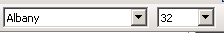
- Bold, Italics, Underline, Shadow
- Left Alignment, Center, Right Alignment and Justified
- Increase and Decrease Font Size
- Font Colour

You can also work only on character formatting by clicking on .
It gives you options to change the:
- font:
  - type, typeface (Italic or Bold), size,
- fonts effects such as:
  - colour, overlining, strikeout, relief, underlining
- position:
  - superscript, normal or subscript
  - scaling
  - character spacing

You can also work on paragraph formatting by clicking on the to:
- indent, spacing between paragraphs, line spacing
- alignment (left, centre, right, justified)
- setting tabs and fill characters

In summary,

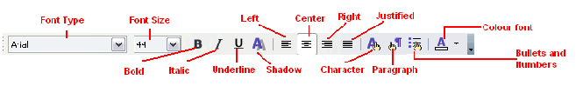

Using the Format Toolbar

To format text, follow the steps below:

- To make formatting changes to text that you have not entered yet, click on the down-pointing arrow (e.g., Font Type. Font Colour) OR the format button that you want to apply to the slide (e.g., Bold, Italic, Underline, etc).
- To make formatting changes to existing text, highlight the text and click on the down-pointing arrow or button.

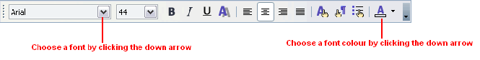

Take some time to experiment with the different formatting options to decide what's best for your presentation.

Using the Format Menu

You can also use the Format menu to make formatting changes to the text in your presentation.

To format text follow the steps below:

- Highlight the text that you want to format.

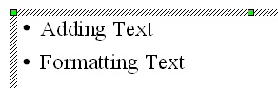

- Click on FormatCharacter on the menu bar.

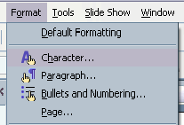

- The Character dialogue box will appear. Select the desired Font, and/or Typeface, and/or Size.

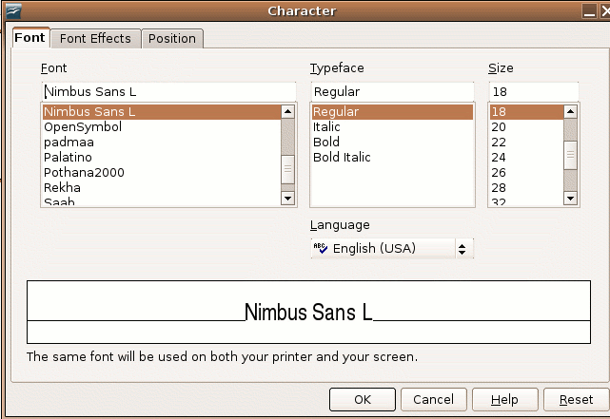

- Click the OK button.

Changing the case of text

Sometimes it is necessary to change the case of a word you have entered. You can change the case of selected characters (highlighted), or if the cursor is in a word, change the case of all of the characters in the word.

- Choose FormatChange Case
- Choose Uppercase – Changes the selected characters/word to capital letters or Lowercase – Changes the selected characters/word to lowercase letters.

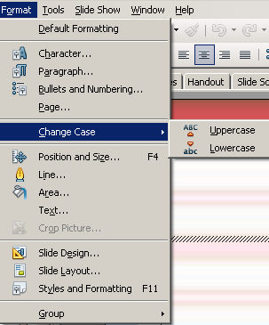

Using Bulleted and Numbered Lists

You can create two different types of lists in Impress:

- bulleted lists
- numbered lists

Bulleted and numbered lists help a reader to simplify steps or items.

Teachers often use bulleted lists to highlight important pieces of their modules. Manuals often include numbered lists to highlight step-by-step instructions.

A bullet by default in Impress is a black circle but it can be customised to any other symbol used to highlight items in a list.

Use bullets to list items that do not have to be in any particular order. Use numbers (or letters) when information has to be in a certain order (or when the count is necessary).

You can use the default bullets by clicking on the appropriate button on the Formatting Toolbar .

Impress provides several bulleted-list template slides that you can incorporate into your presentation. You can use these slides or create new slides on your own.
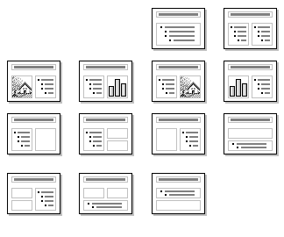

Creating a Bulleted List

To Create a Bulleted List follow the steps below:

- Highlight the text that you want to convert into a bulleted list.

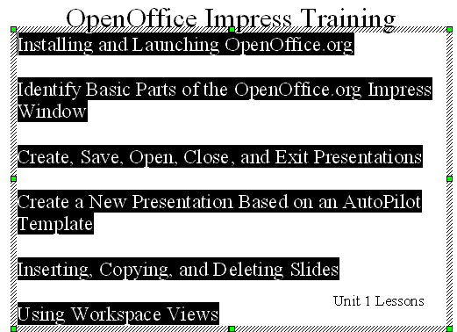

- Click the Bullet button on the Formatting toolbar.

Formatting a Bulleted List

It is important to remember that if you want to change the format of a bulleted list or use a format bullet that is not the default, you need to click on the Bullets and Numbering button.

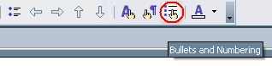

You must:

- Highlight the text that you want to convert into a bulleted list/change the format of the bullets.
- Either choose the icon on the toolbar or choose FormatBullets and Numbering on the menu bar.

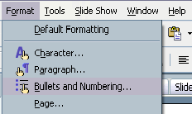

- Click the Bullets tab on the Bullets and Numbering dialog box.

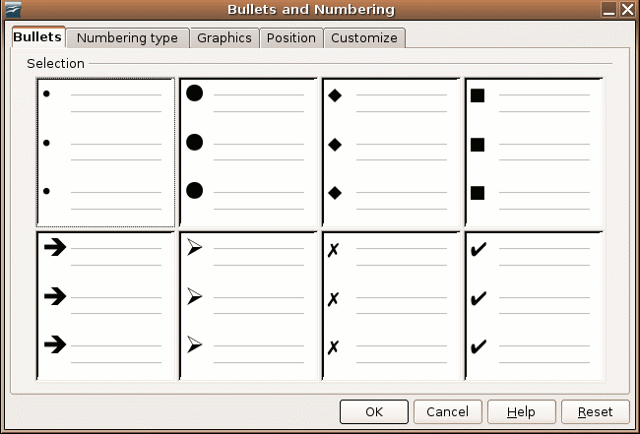

- You could also use bullet graphics instead of the standard bullets, by clicking the Graphics tab on the Bullets and Numbering dialog box.

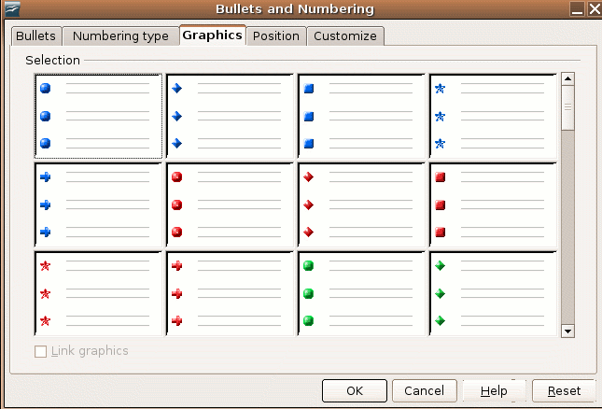

- Click to select a bullet style from the examples that are displayed in either the Bullets tab or the Graphics tab.
- Click the OK button.

To create a line break between items in a bulleted or numbered list, place your cursor where you want the line break and press Shift + Enter.

To indent bulleted text, place the cursor just after the bullet. You can press the tab key (to follow the indentation of the Master) and the backspace to get to the previous level.

Creating and Formatting a Numbered List

To create a Numbered List on existing text:

- Highlight the text that you want to convert into a numbered list.

- Either choose the icon on the toolbar or choose FormatBullets and Numbering on the menu bar.

- Click the Numbering type tab on the Bullets and Numbering dialog box.

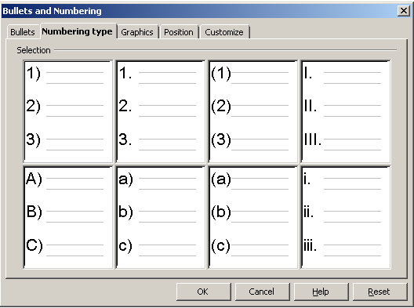

- Click the OK button.

To create a Numbered List while you are entering text, follow the steps above before you are entering text.
Tip: To set the indent, spacing and alignment options for the numbered or bulleted list, Choose FormatBullets and Numbering. Open Position tab page.
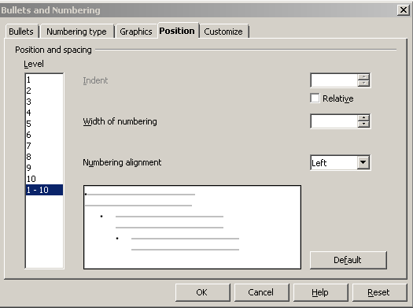

- In the Level space – Select the level(s) that you want to modify.
- In the Indent space – Set the indent size. If you mark Relative, it indents the current level relative to the previous level in the list hierarchy.
- In Width of numbering space – Enter the amount of space to leave between the left edge of the numbering symbol and the left edge of the text. Set the size you want.
- In Numbering alignment space – Set the alignment of the numbering symbols. Select “Left” to align the numbering symbol to start directly at the “Aligned at” position. Select “Right” to align the symbol to end directly before the “Aligned at” position. Select “Centered” to center the symbol around the “Aligned at” position.
- When you hit Default it resets the indent and the spacing values to the default values according to the Master.

Work with Tables in Presentations

To create tables in presentations, you have to understand the terms outlined in Module 2 and 3, viz. rows and columns.

Create a Table Slide, Enter and Edit Text

To create a table slide, change the layout of an empty slide to a Table Slide
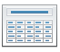

Double click in the Table Box to add a spreadsheet.

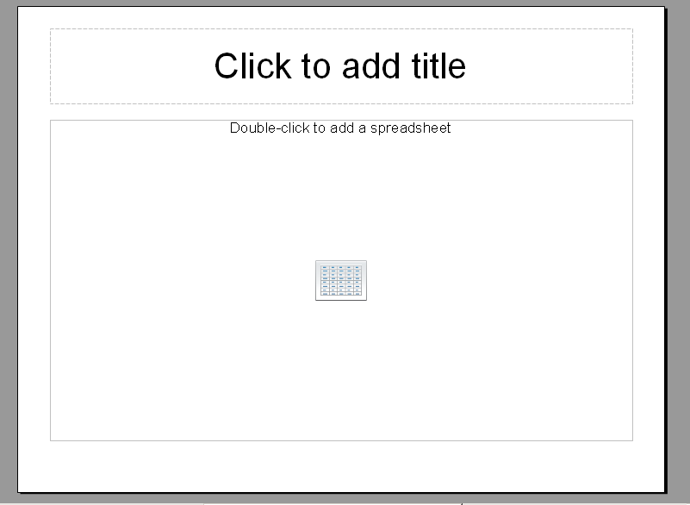

A spreadsheet appears on the Table Box. Enter your text in the different rows and columns. You can format the text, adjust the column width and row height as you have learned in Module 3. You can also insert formulas, exactly as in a spreadsheet.

Remember to adjust the size of your text so that it is clearly visible on the slide.

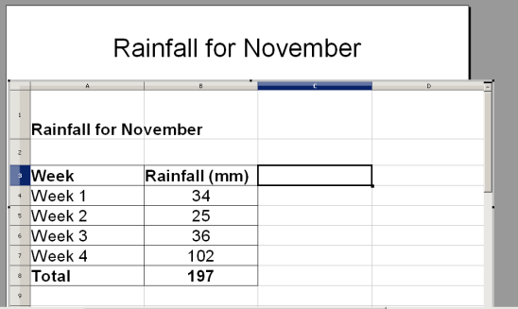

When you are finished, just click on the slide outside the spreadsheet.

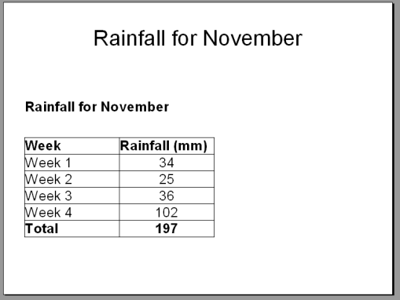

To return to the spreadsheet, double click inside the table.

When practicing the above, ensure that you are able to:

- open a table slide
- activate the spreadsheet
- enter and edit text
- select rows, columns and the entire table
- insert and delete rows and columns
- change the column width and row height
- adjust the font size and appearance (bold, italic, colour, different font)
- change the background colour of some cells
- change the alignment of text in cells (left, right, center)
- wrap text in a cell
- insert borders in your table
- deactivate the spreadsheet
- modify text in the table after you have deactivated the spreadsheet

Insert a Table in a Slide, Enter and Edit Text

You can also insert a table on a blank slide by:

- Choose InsertTable on the menu bar.
- Enter the number of columns and rows of your table and hit OK.

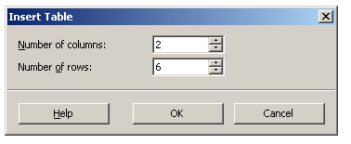

- A Table Box appears in the slide.

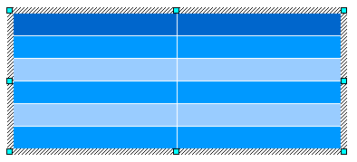

- You are now able to enter and format text as above.

Note: This way does not have the flexibility of a spreadsheet (e.g. formulas) and can be limiting. An advantage of this way is that you can resize the table by grabbing the handles on the perimeter of the Table Box.


Self Assessment

You have to develop a slide on the attendance by gender for monthly courses.

Start by developing the following table of half year training statistics on a slide.

Months | Females | Males | Total
January | 10 | 12 | 22
February | 21 | 13 | 34
March | 0 | 0 | 0
April | 12 | 6 | 8
May | 10 | 9 | 19
June | 8 | 4 | 12
Total | Use a formulae | Use a formulae | Use a formulae

Format the table as shown below. Do not enter the totals, use formulae.
Resize the table so that it fits the whole slide as shown below.

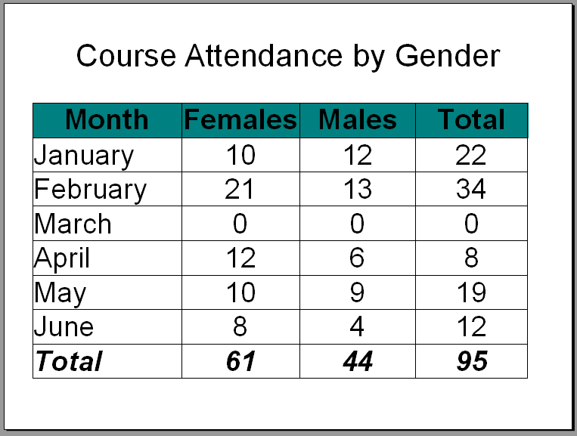

Summary

In this section you have worked with and formatted text. You have to ensure that you are confident in working with lists and tables in your presentations.

By now you must be able to:

- use standard and outline view to enter text
- edit, copy, move, delete text within and between presentations
- use the undo, redo command
- apply and change formatting of text
- edit bullet and numbered lists
- create, populate and format a table slide

Working with Charts

Section Overview

As we have learnt in the first section of this module, it is very good to use charts and graphical representation of data in slides.

As with tables you can both insert Charts and import Charts from Spreadsheets.

By the end of this section, you will be able to:

- input data to create built-in charts in a presentation: column, bar, line, pie
- change the chart type
- add data labels to a chart
- change colours of a chart

Inserting Charts

A chart is a type of information/data graphic or graphic organiser that represents tabular numeric data and/or functions.

Charts are often used to visually represent large quantities of data and the relationship between different parts of the data for ease of understanding.

Charts can usually be read more quickly than the raw data that they come from.

Charts add visual interest and useful information represented by lines, bars, pie slices, or other markers.

Understanding the Different Chart Types

Impress allows you to create many different kinds of charts to visually accent data.

Column Chart

A column chart uses vertical bars or columns to display values over different categories. This chart shows variation in value over time.

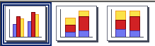

Bar Chart

A bar chart is similar to a column chart except these use horizontal instead of vertical bars. Like the column chart, the bar chart shows variation in value over time.

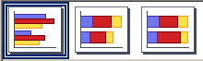

Pie Chart

A pie chart displays the contribution of each value to the total. Pie charts are a very effective way to display information when you want to represent different parts of the whole, or the percentages of a total.



Area Chart

An area chart emphasises the trend of each value over time. An area chart also shows the relationship of parts to a whole.

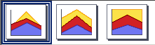

Line Chart

A line chart shows trends and variations in data over time. A line chart displays a series of points that can be connected.



Other Charts

Some of the other charts that you can create in Impress include XY Chart, Net chart, Stock chart, Line (3D) chart, Area (3D) chart, Bar (3D) chart, Column (3D) chart, and Pie (3D) charts.

Identifying the Parts of a Chart

Have you ever read something you didn’t fully understand but when you saw that same information in a chart or graph, the concept became clear and understandable? Charts make it easy to see comparisons, patterns, and trends in the data.

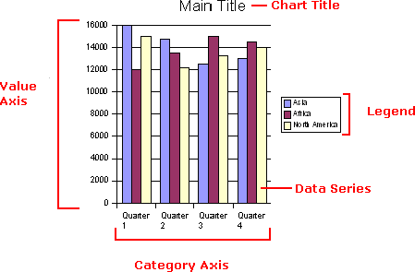

Data Source

The Data source of a chart is a table containing data (text or numbers). The chart is updated automatically whenever the information in the table changes.

Title

The title of the chart.

Legend

The chart key lists each colour used in the chart and identifies what that colour represents on the chart.

Axis

The vertical and horizontal parts of a chart. The vertical axis is often referred to as the Y-axis, and the horizontal axis is referred to as the X-axis.

Data Series

The actual charted values, usually rows or columns, of the source data.

Value Axis

The axis that represents the values or units of the source data.

Category Axis

The axis identifies each data series.

Inserting a Simple Chart

Start on a new slide.

- In the Layout pane, click any of the 3 layouts that contain a chart.

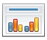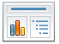

- Double click on the Add Chart Icon to add a chart. A Chart Box appears with the default chart displayed in it.

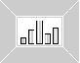
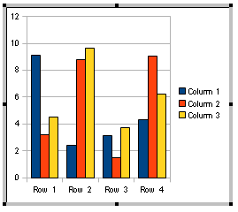

- First you have to develop your Data Source (Data Table). Right-click on the chart. In the menu, click Chart Data Table.

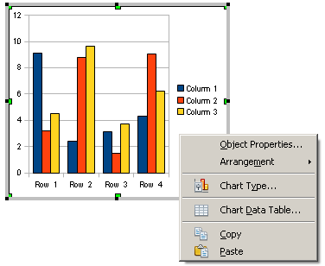

- Enter the information from the table in the datasheet provide. Use the buttons on the top to add and delete rows and columns.

- Enter the data as in the table below.

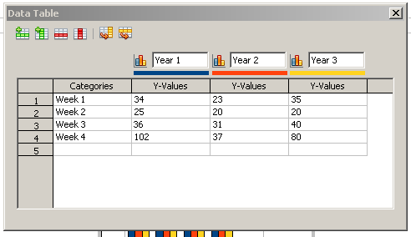

- Close the data source by clicking on the .

- The chart is now updated with the information in your data source (table).

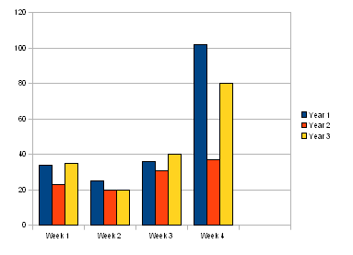

Changing the Chart Display

When you double click on the Chart Box a formatting toolbar appears.

- With the first button you can change the chart type.

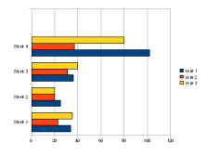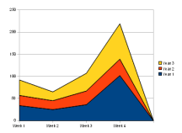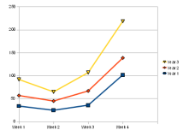

- The second button allows you to go back to your data source (table).
- The third button (horizontal grid on/off), allows you to remove the horizontal lines in the chart.

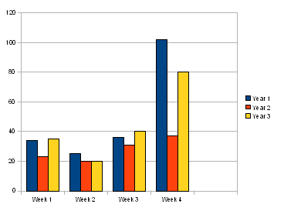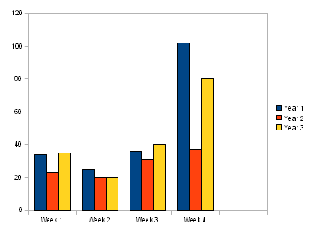

- The fourth button allows you to remove the legend on the side.

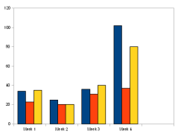

You can also insert a chart by choosing InsertChart.

Changing the Chart Title, Appearance of the Axes, Grids, Legend and Data Labels

With Impress, you can add and change a chart title, change the appearances of the axes, grids, legend and data labels.

Insert and Change Chart Title and Axes Labels

To insert a Chart Title, choose InsertTitle. You can type in a title, sub-title and labels for the axes.

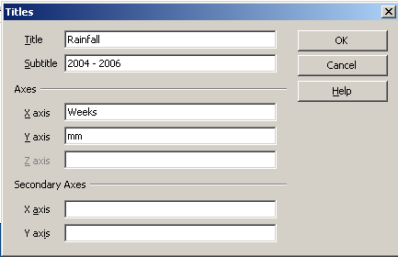

When hitting OK, your chart will look like this:

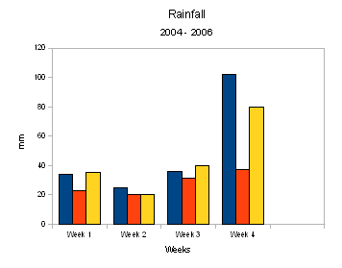

You can change the Chart Title at any time to accurately represent the data that is in your chart. To change the chart title on the chart:

- Display the slide that contains the chart that you want to edit.
- Double-click the chart to select it for editing.
- Double-click the Chart Title to select it for editing and change the content.

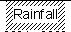

- Click anywhere outside of the title to apply your changes.

Change Appearance of Axes

You can also change the appearance of the axes by InsertAxes. If you untick one of the axes, the axis will not appear on your chart.

Change Appearance of Grids

You can also change the appearance of the grids by InsertGrids. You can tick if you want horizontal and/or vertical gridlines to appear on your chart.

Major grids are gridlines with big intervals and minor grids are gridlines with small intervals (more gridlines appear on your chart).

Change Appearance of Legend

You can also change the appearance of the legend by InsertLegend. You can tick if you want a legend or not, and then you can place it at the top, left, bottom or right of the chart.

You can also change the size of a legend or move it around by clicking on the legend.

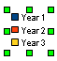

Insert and Change the Appearance of Data Labels

Sometimes a chart needs exact value of the data displayed. That is called data labels. You can insert data labels by InsertData Labels. You can tick if you want the data label as:

- Numbers

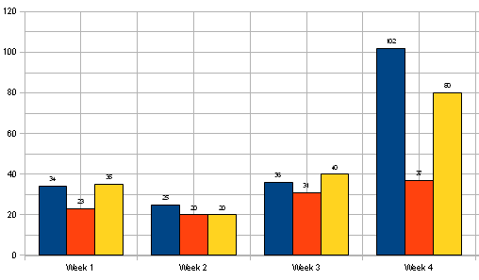
- Percentage
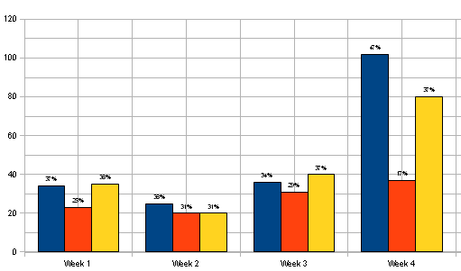
- Show as a category
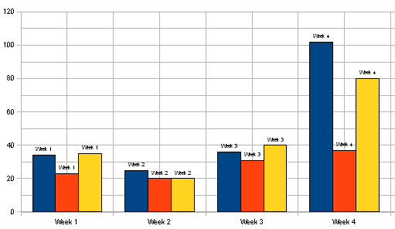
- Show as a legend key

Changing the Background Colour of a Chart

The default white background can be too bright for a presentation and you might want to change the background colour of the chart.

- Activate the Chart Box by double clicking on the chart.
- Click on the background of the chart to mark the background.

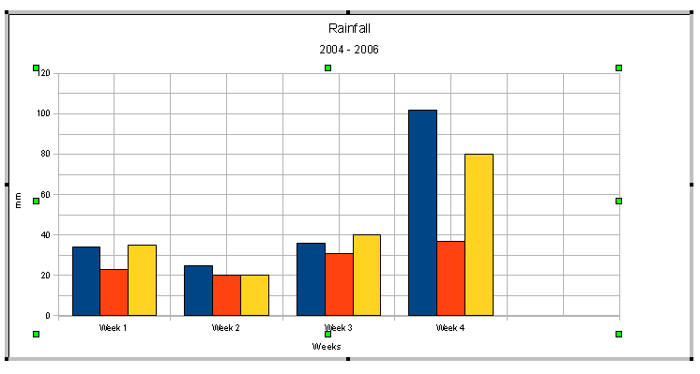

- Right click, choose object properties.

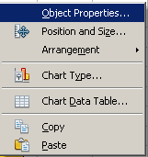

- Ensure that the words Chart Wall appear on the top of the menu. Choose Area and choose from the drop-down menu how the background of your chart must look. You can choose, colour, gradient, hatching or bitmap (see the difference on pages 30–31).
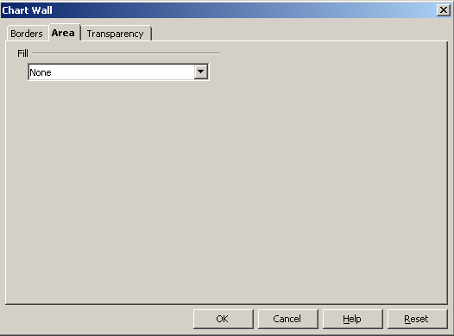

Remember the rule of backgrounds – it must not be too busy or too dark to distract the message of your chart.

Importing Charts and Tables from a Spreadsheet

We went through the process of creating tables and charts in your presentation. We are now moving a step further and import already created files into our presentation. For this, we will use OpenOffice.org Calc.

As you may be aware of by now, spreadsheets have better and more versatile mechanism of managing and presenting more complex data. All this data might not fit or serve the purpose of a presentation.

Inserting a new Spreadsheet: A Recap

You can add a blank OpenOffice.org Calc spreadsheet to a slide as an Object Linking and Embedding (OLE) object. That means that you will have a Calc document within your Impress document.

- Go to the slide where you want to insert the spreadsheet.
- Do one of the following:
Insert a spreadsheet as an OLE Object:
- Choose InsertObjectOLE ObjectCreate newOpenOffice.org 3.1 Spreadsheet.

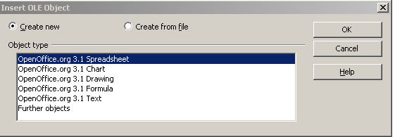

Hit OK. An empty spreadsheet will appear on your slide.

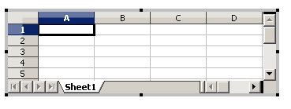

- Make the spreadsheet bigger by grabbing and pulling the corner handles around the spreadsheet.
- Click in the spreadsheet to enter and format your data (see page 59-60).

Insert a spreadsheet through the Layout pane:

- Open the Layout pane, and double-click the table layout.
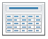
- Follow the instructions on page 59-60.

- To resize the table select the object in the slide (not the spreadsheet) and then drag a corner handles.
- To resize the cells of the spreadsheet, double-click to get into the spreadsheet, and then resize the cells (column width and row height).

Inserting Spreadsheets from a File

When you insert an existing spreadsheet into your slide, changes that are made to the original spreadsheet file are not updated on your slide. You can, however, make changes to the spreadsheet in your slide.

- Go to the slide where you want to insert the spreadsheet.
- Choose InsertObjectOLE ObjectCreate from file

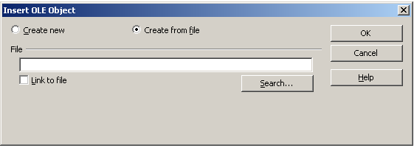

- Locate the file you want to insert, and then click OK.

The entire spreadsheet is inserted into your slide. If you want to change the sheet that is displayed, double-click the spreadsheet, and then select a different sheet.

Summary

In this section you have learnt how to use charts and graphical representation of data in slides.

You are now able to:

- input data to create built-in charts in a presentation: column, bar, line, pie
- change the chart type
- add data labels to a chart
- change colours of a chart

Working with Graphics

Section Overview

“A picture is worth a thousand words”.

Pictures and images present information in a format that is easy to understand and can be visualised. In short, it adds value to your presentation and makes it look more appealing than using just text!
By the end of this section, you will be able to:

- insert a graphical object into a slide
- edit a graphical object in a slide
- copy, move and delete a graphical object in a presentation and between presentations
- apply drawing tools to create images

What is a Graphical Object?

A graphical object can be:

- picture, image, drawn object or photo stored in a file (.jpeg, .bmp, .gif, .tiff)
- Clip Art (refers to pre-made images stored in a gallery in a program)
- drawing – graphical shapes such as a rectangle, oval, arrow or stars.

To edit the detail in a graphic, e.g. to take out parts of a photo or to manipulate a photo, is normally done by Graphic Programs such as Photoshop or GIMP (GNU Image Manipulation Program). GIMP is a free software raster graphics editor. Primarily, GIMP is used as a tool for photo manipulations, such as resizing, editing, and cropping photos, combining multiple images, and converting between different image formats.

You can however manipulate graphics to a certain extent with an Office Application such as Impress.

Inserting Clip Art

Using the Gallery

First locate the Drawing Toolbar on your desktop. You will use it extensively in this section.

The drawing toolbar can be located in a floating panel or on the top or bottom of the Impress screen.

To view the Drawing toolbar, choose ViewToolbarsDrawing.
There are a number of ways of accessing the Gallery in Open Office Impress.

To insert Clip Art from the Gallery:
- Go to the relevant slide.
- Choose ToolsGallery.

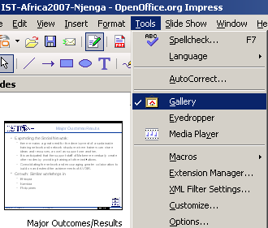
or:
- Click on the Gallery icon .

The Gallery window is displayed with a number of coloured graphics (pictures).

On the left side of the Gallery window are the words, Backgrounds, Bullets, etc. These words are the names of different Themes. You will find that there are many images in your My Theme tab. (If no images are displayed, please refer to the Install section at the beginning of this course.)

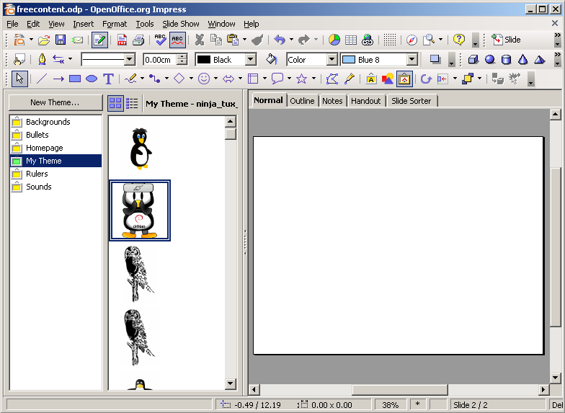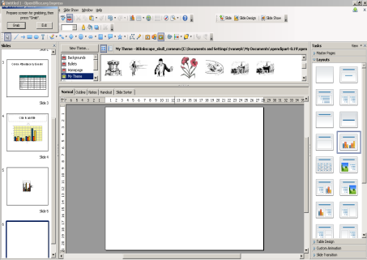

To use an image, drag and drop it to your Workspace on the slide.

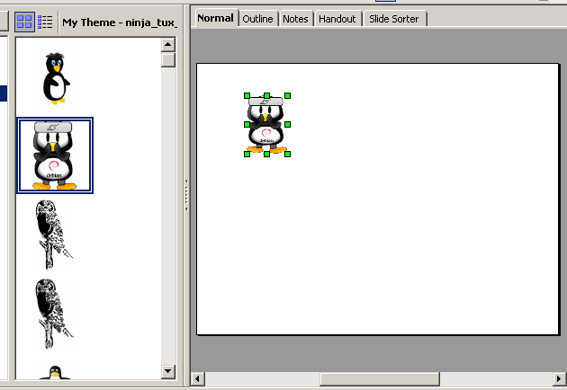

Inserting an Image from File

You can also add your own images into your presentation. Impress offers a number of ways to insert an image from file.

Using the Layout Template

If you have already saved the picture, and you would like to insert it, you can use the layout template. On your Task Pane, select on the Layout one of the layouts showing an image.

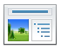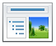

Double click on the image place holder for a file system browser to pop up as shown. Browse to the location of your image and select the image by hitting Open.

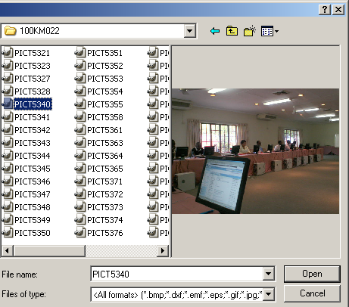

The image selected will be inserted to the slide as shown below.

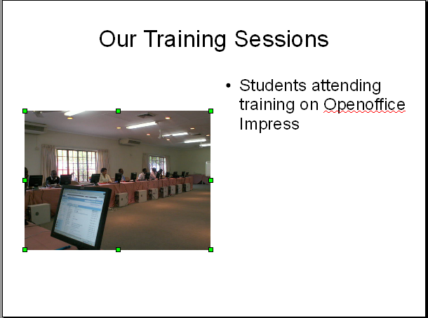

Remember you can get rid of the bulleted text boxes by deleting them and resize the image.

Using the Menu

If you have already saved the picture, and you would like to insert, go to InsertPictureFrom File.

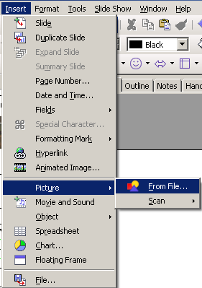

Browse to the location of your picture. Select your file, and click “Insert”. Your picture will appear on the current slide.

Copying from another Application or File

Images can also be pasted into your Impress presentation. If you have an image within another source, copy the image from the original source. Go to your current application and paste the art work into your presentation (See page 49 – 51).

Pasting from GIMP

If you have your image open in your graphics editor of choice, in this case GIMP, you can copy the image and paste it directly onto your slide.

First go GIMP. In GIMP, there are a number of ways of copying an image or sections of an image. One of them is, with your image open, Right-clickEditCopy as shown below.

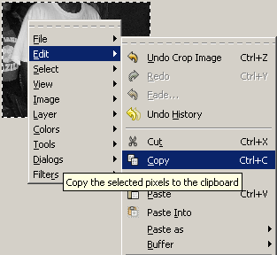

With your image on the clipboard, go to the slide where you would like to past it and right-click on the slide and click on Paste.

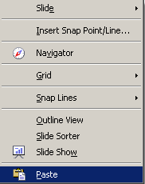

The image will appear on the slide as shown below.

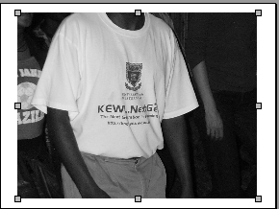`

Moving Graphics

Using the Mouse

- Click on the graphic/picture/image. The mouse pointer turns into a four-way arrow like this.

- Click on the picture and drag it to the desired place on your page.

Using the Position and Size Window

- In the dialog box on the Position you can alter the position by typing in numbers in the width and height, or using the slide (up and down allows).
- Click the OK button (The picture changes location).

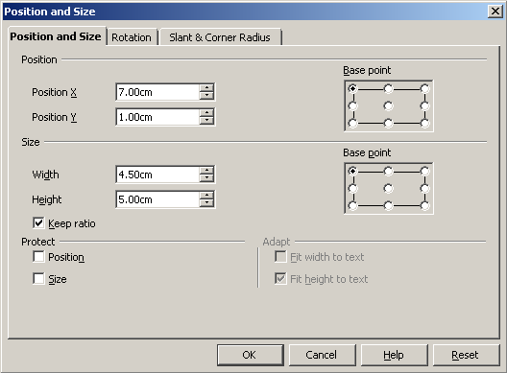

Resizing Graphics

There are two ways of resizing a graphic/picture/image.

Using the Mouse

- Click on the picture and eight points (green squares), called handles, will appear along the sides of the picture as shown in the figure above).
- Place your pointer on any of the points. Click and drag the mouse to modify the picture (A double-headed arrow in the directions shown below will appear).

- To keep the proportions of the graphic, press and hold the Shift key. Click and drag a handle of the picture. Release the mouse button to complete the resize.
- When you have changed the picture to the desired size, click anywhere on the page except on the picture.

Using the Position and Size Window

- Right-click anywhere on the picture. (A menu appears)

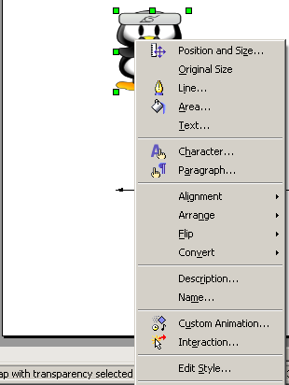

- Click Position and Size. (The Position and Size window appears)

- On the Size, you can alter the size by typing in numbers in the width and height, or using the slide (up and down allows). To keep the dimensions of the image, check the Keep ratio.

Rotate Graphics

You can rotate graphics (put it at an angle for example) using the Format menu:

- Choose FormatPosition and Size
- Click on the Rotation tab in the Position and Size dialogue box
- Adjust the Rotation angle spin window or
- Click on one of the Default settings
- Click OK

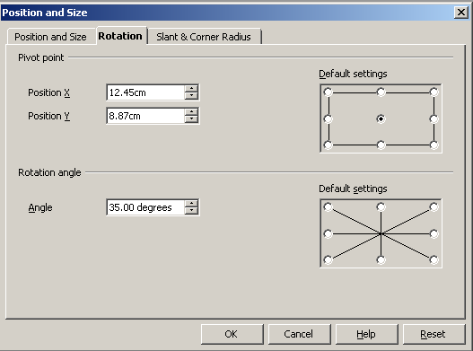 or 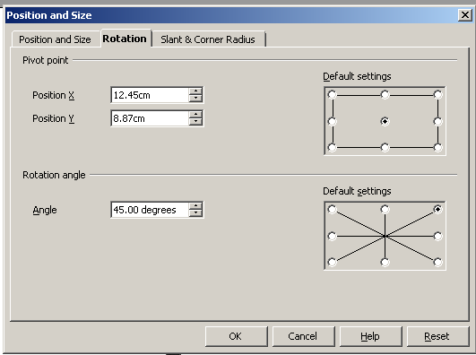

Result:

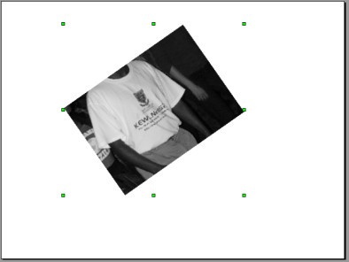

You can also use the icon on the drawing toolbar. The handles turn to red and the centre of rotation is marked.

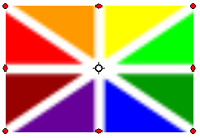
When you hover the mouse over one of the red dots you will see a rotation signal over the handle. Pull on the handles to rotate the graphic.

Flip Graphics

You can flip graphics (mirror images sideways or downwards) by right clicking on the image:

- Choose Flip
- Choose Horizontally or Vertically
Vertically means flip the selected object(s) vertically from top to bottom.

Horizontally means flip the selected object(s) horizontally from left to right.

You can also flip an image by pulling the handles past the image. It will flip in the direction you have pulled it.

Align Graphics

You are also able to align graphics on the slide viz. left, center, right and top, center, bottom. Right click on the image:

- Choose Alignment
- Choose left, center, right and top, center, bottom

You can also make use of the button on the drawing toolbar (activate the dropdown menu to make your choice).

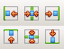

Changing the Order of Graphics

Sometimes you want a certain graphic to be in front of another, or in front of text.

For example, you have the following slide:

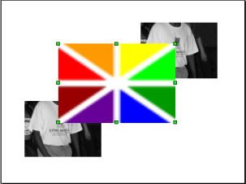

By right clicking on the coloured image, choose Arrange and look at the options provided.
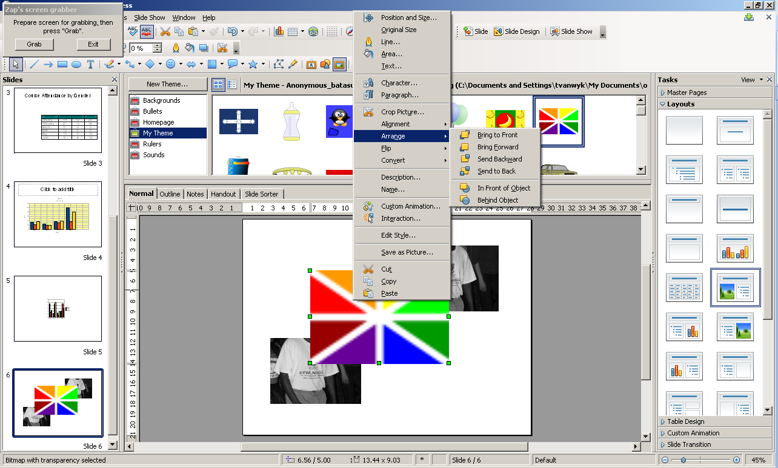
In this case if you choose Send Backward, it will go one layer back.
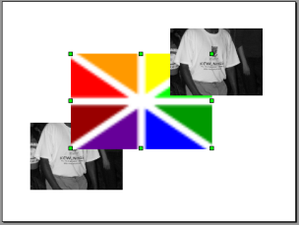
If you choose Send to Back, it will appear at the back of all the images.
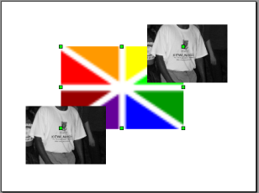
You can also make use of the button on the drawing toolbar (activate the dropdown menu to make your choice).

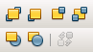

Using the Art Gallery to Draw Objects

Draw Objects are defined as lines, arrows, block arrows, rectangles, squares, ovals, circles and others. (In this part we will also handle text boxes.)

OpenOffice provides a host of tools that can be used for drawing user defined images.

For example you would like to put a custom process that your learners go through from the time they apply for admission, through to the time they graduate or leave your organisation. While you can draw this process on paper and scan it for eventual migration to your presentation, you can also use the drawing tools provided. This will make your presentation neater and more appealing.
Know the Drawing Tools

First locate the drawing toolbar.

If floating it looks like this:

The table below summarises all the frequently used icons.

Icon | Description
 | Click this button to then select and move objects on your slide.
 | Allows you to draw lines by clicking and dragging on your slide.
 | Allows you to draw arrows by clicking and dragging on your slide.
 | This tool allows you to insert rectangles and squares.
 | This tool allows you to insert ovals and circles.
 | This tools inserts a text box in which you can type an unlimited amount of text in your presentation. You do this by clicking this tool and then clicking in your slide.
 | This tool allows you to draw lines or curves. The dropdown arrow on the right of the graphic gives additional options.
 | This tool allows you to connect graphics to create flow charts or diagrams.
 | This tool gives you the option to insert pre-designed shapes such as diamonds, pentagons and cylinders. Note the dropdown arrow on the right of the graphic that gives additional options.
 | This tool gives the option to insert pre-designed fun shapes such as hearts or happy faces. Note the dropdown arrow on the right of the graphic that gives additional options.
 | This tool allows you to insert block shaped arrows. Note the dropdown arrow on the right of the graphic that gives additional options.
 | This tool allows you to insert flowchart shapes. Note the dropdown arrow on the right of the graphic that gives additional options.
 | This tool allows you to insert callouts. Note the dropdown arrow on the right of the graphic that gives additional options.
 | This tool allows you to insert different star and banner shapes. Note the dropdown arrow on the right of the graphic that gives additional options.
 | This tool allows you to change the size of points on a vector-created image. Click on the image and then click on a handle box. Drag the handle box to a different location to edit the vector-based image.
 | This tool displays the points on a custom-drawn object. Click once on the object to select, then click on the glue point icon to display points on the object. The glue points can then selected and moved to alter the image.
 | This tool gives you some dramatic, pre-designed styles for formatting your text called the Fontwork Gallery.
 | This tool allows you insert pictures from file.
 | This tool opens a gallery of images, sounds, bullets, web page icons, and rule dividers that can be inserted into a presentation for sound and graphic appeal.
 | This tool allows you to rotate an object by clicking on the object. When a circle handle appears, click on the circle and rotate the object by moving the mouse.
 | This tool allows you to change the alignment of objects. Note the dropdown arrow on the right of the graphic that gives additional options.
 | This tool allows you to change the layering of objects. Objects can be moved backwards or brought forward. Note the dropdown arrow on the right of the graphic that gives additional options.

You also have to locate the Line and Filling Toolbar on your desktop. You will use it extensively in this section.

The Line and Filling toolbar can be located in a floating panel or on the top or the bottom of the Impress screen.

To view the Line and Filling toolbar, choose ViewToolbarsLine and Filling.
Icon | Name | Description
 | Line | This tool allows you to change the width and style of lines. It can also be accessed by right mouse clicking on an object.
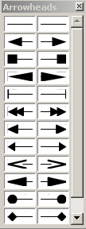 | Arrow Style | This tool allows you to change the direction and arrow head by clicking on a line or arrow that has been added to the presentation. It can also be accessed by right mouse clicking on an object
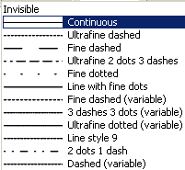 | Line Style | This tool allows you to adjust the line format.
 | Line Width | This tool adjusts the line width by entering the desired width.
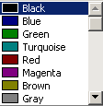 | Line Color | This tool allows you to change the line colour of objects.
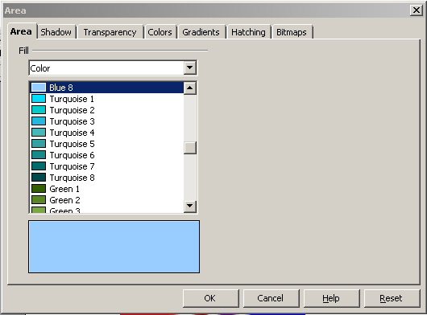 | Area | This tool opens different windows that give you many options for changing the fill, colour, gradient, and texture of a shape object.
 | Area Style/Filling | This tool is a two part tool. Select an option from the first window, such as gradient. Review the many choices for gradient in the second window and click on one to choose it.
 | Shadow tool | This tool applies a shadow.

Using the Drawing Tools

Drawing tools give you a selection of different drawings to use.

Lines

You can draw different kinds of lines, arrows, connectors and curves by clicking on the appropriate icon as shown below.

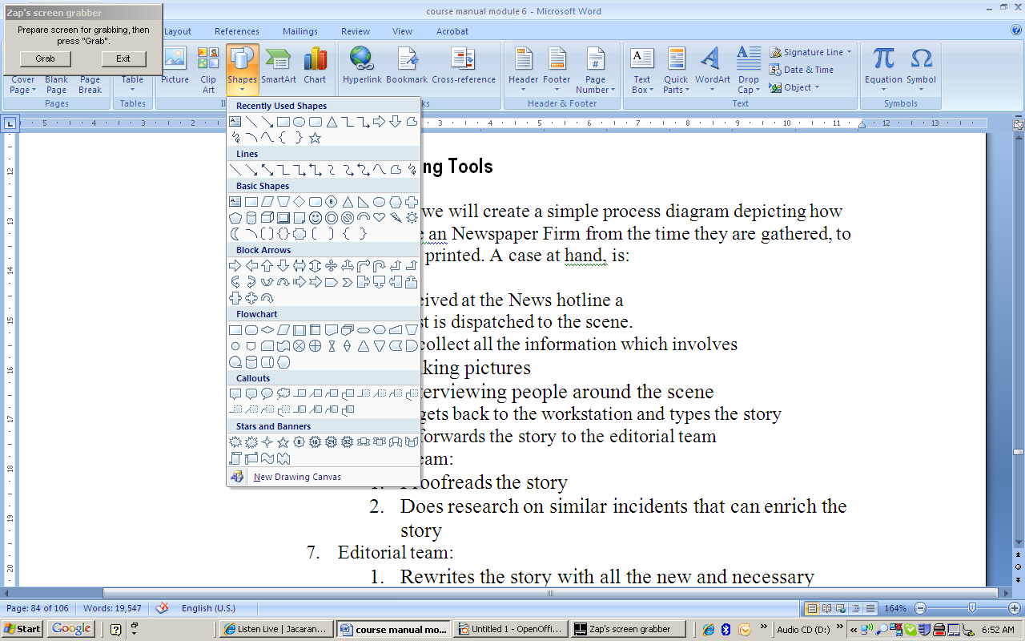

Because a line is a graphic, you can delete, move, copy and paste, resize, rotate, flip, align and change the order of a line by the same ways as discussed on page 77 – 81.

When you click on a connector or curve, it gives you a series of handles to pull to change the appearance of the graphic.

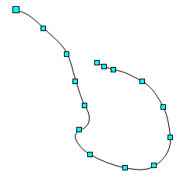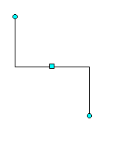

To change the features of the line, arrow, curve or connector, you can click on the icon or right-click and select the same icon:

- Line style, colour, width and transparency
- Arrow styles
- Corner styles
- Shadows

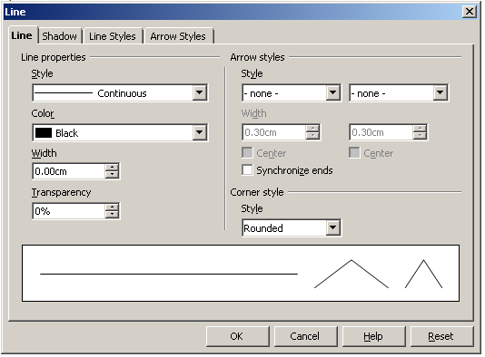

Other Drawing Objects

You can draw different kinds of drawings in Impress (Check the dropdown menus under each of the tools).

This tool allows you to insert rectangles and squares. You can:
- delete, move, copy and paste, resize, rotate, flip, align and change the order in the same ways as discussed on page 77 – 81.
- change its lines by the icon, including:
  - line style, line colour, width and transparency
  - corner styles
  - shadows
- change the fill colour, gradient, and texture by the area icon or right click on the drawing and choose Area
- add text to the shape by clicking on the shape and choose icon. You can format the text as you have done before (size, bold, italics, underline, alignment, etc). Then you can further change the format of the text by right clicking on the shape and choose the different options.
This tool allows you to insert ovals and circles. You can:
- delete, move, copy and paste, resize, rotate, flip, align and change the order in the same ways as discussed on page 77 – 81.
- change its lines by the icon, including
  - line style, line colour, width and transparency
  - corner styles
  - shadows
- change the fill colour, gradient, and texture by the area icon or right click on the drawing and choose Area
- add text to the shape by clicking on the shape and choose icon. You can format the text as you have done before (size, bold, italics, underline, alignment, etc). Then you can further change the format of the text by right clicking on the shape and choose the different options.
This tool gives you the option to insert pre-designed shapes such as diamonds, pentagons and cylinders. Note the dropdown arrow on the right of the graphic that gives additional options.
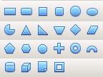
You can:
- delete, move, copy and paste, resize, rotate, flip, align and change the order in the same ways as discussed on page 77 – 81.
- change its lines by the icon, including
  - line style, line colour, width and transparency
  - corner styles
  - shadows
- change the fill colour, gradient, and texture by the area icon or right click on the drawing and choose Area
- add text to the shape by clicking on the shape and choose icon. You can format the text as you have done before (size, bold, italics, underline, alignment, etc). Then you can further change the format of the text by right clicking on the shape and choose the different options.
This tool gives the option to insert pre-designed fun shapes such as hearts or happy faces. Note the dropdown arrow on the right of the graphic that gives additional options.
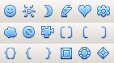
You can:
- delete, move, copy and paste, resize, rotate, flip, align and change the order in the same ways as discussed on page 77 – 81.
- change its lines by the icon, including
  - line style, line colour, width and transparency
  - corner styles
  - shadows
- change the fill colour, gradient, and texture by the area icon or right click on the drawing and choose Area
- add text to the shape by clicking on the shape and choose icon. You can format the text as you have done before (size, bold, italics, underline, alignment, etc). Then you can further change the format of the text by right clicking on the shape and choose the different options.
This tool allows you to insert block shaped arrows. Note the dropdown arrow on the right of the graphic that gives additional options.
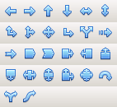
You can:
- delete, move, copy and paste, resize, rotate, flip, align and change the order in the same ways as discussed on page 77 – 81.
- change its lines by the icon, including
  - line style, line colour, width and transparency
  - corner styles
  - shadows
- change the fill colour, gradient, and texture by the area icon or right click on the drawing and choose Area
- add text to the shape by clicking on the shape and choose icon. You can format the text as you have done before (size, bold, italics, underline, alignment, etc). Then you can further change the format of the text by right clicking on the shape and choose the different options.
This tool allows you to insert flowchart shapes. Note the dropdown arrow on the right of the graphic that gives additional options.
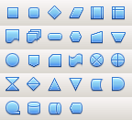
You can:
- delete, move, copy and paste, resize, rotate, flip, align and change the order in the same ways as discussed on page 77 – 81.
- change its lines by the icon, including
  - line style, line colour, width and transparency
  - corner styles
  - shadows
- change the fill colour, gradient, and texture by the area icon or right click on the drawing and choose Area
- add text to the shape by clicking on the shape and choose icon. You can format the text as you have done before (size, bold, italics, underline, alignment, etc). Then you can further change the format of the text by right clicking on the shape and choose the different options.
This tool allows you to insert callouts. Note the dropdown arrow on the right of the graphic that gives additional options.
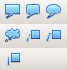
You can:
- delete, move, copy and paste, resize, rotate, flip, align and change the order in the same ways as discussed on page 77 – 81.
- change its lines by the icon, including
  - line style, line colour, width and transparency
  - corner styles
  - shadows
- change the fill colour, gradient, and texture by the area icon or right click on the drawing and choose Area
- add text to the shape by clicking on the shape and choose icon. You can format the text as you have done before (size, bold, italics, underline, alignment, etc). Then you can further change the format of the text by right clicking on the shape and choose the different options.
This tool allows you to insert different star and banner shapes. Note the dropdown arrow on the right of the graphic that gives additional options.
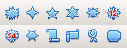
You can:
- delete, move, copy and paste, resize, rotate, flip, align and change the order in the same ways as discussed on page 77 – 81.
- change its lines by the icon, including
  - line style, line colour, width and transparency
  - corner styles
  - shadows
- change the fill colour, gradient, and texture by the area icon or right click on the drawing and choose Area
- add text to the shape by clicking on the shape and choose icon. You can format the text as you have done before (size, bold, italics, underline, alignment, etc). Then you can further change the format of the text by right clicking on the shape and choose the different options.
You can combine any graphics and drawings on a slide. An example is a slide depicting how a news event flows in a Newspaper Firm from the time it is gathered, to the time it is published.

The process the slide wants to show is:

- Call is received at the News hotline.
- A journalist is dispatched to the scene.
- Journalist collects all the information which involves:
  - Taking pictures.
  - Interviewing people around the scene.
- Journalist gets back to the workstation and types the story.
- Journalist forwards the story to the editorial team.
- Editorial team:
  - Proofreads the story.
  - Does research on similar incidents that can enrich the story.
- Editorial team:
  - Rewrites the story with all the new and necessary information; or
  - Sends it back to journalist for corrections or updates.
- The story is sent to the desktop publishers who do the type-setting.
- The story is printed.

For this purpose, the flowchart shapes would be the best.

The slide can look like this:

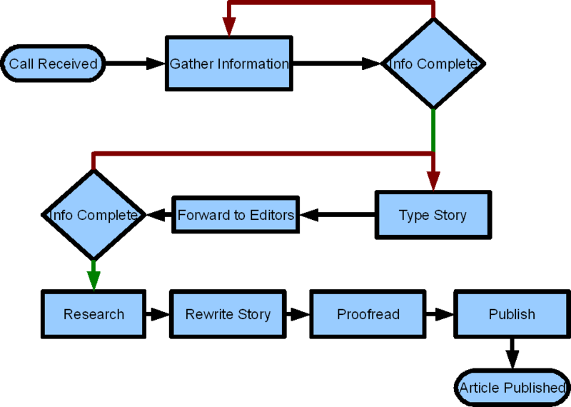

We have made use of the convention used in flow diagrams (often in IT).

Symbol | Name of Symbol | Description | Steps/stages
 | Terminator | Terminators show the start and stop points in a process. When used as a Start symbol, terminators depict a trigger action that sets the process flow into motion. | - call received  - story published
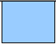 | Process | Show a Process or action step. | - Interview  - Type  - Proofread  - Research  - Rewrite  - Publish
 | Decision | Indicates a question or branch in the process flow. Typically, a Decision flowchart shape is used when there are 2 options (Yes/No, No/No-Go, etc.) | - Decision to send back to the journalist or go on with publishing
 | Connector | Shows a jump from one point in the process flow to another | - Connecting the processes, decisions, and Terminators

To join, we used the arrow and connector tools to join the various workflow elements. We used a colour legend for the arrows for the decision shapes. A green for the right to go ahead, and red for the task to go back or to be rectified.
The result is much more visual, descriptive and would look much better and will be more effective when showing to an audience than using the words.

Working with a Group of Objects (images/pictures/graphics/ drawings)

Move/Delete/Copy a Selection of Objects

Sometimes you want to move/delete/copy a selection of objects. It can be quite a task to move them individually.

Use the select icon and select all the objects by drawing a rectangle around it. You can also click on one, hold down the Shift button and click on the next one. Continue until you have selected all the objects you want to move/delete/ copy.

To move the selection hold down the Ctrl key and move the selection with your mouse.

To copy and paste the selection:

- Hold down the Ctrl key and click on the selection with your mouse.
- Without releasing the Ctrl key or the mouse, press down the Alt key and drag the selection.

You can also use any of the other means to copy/move.

To delete, hold down to Ctrl key and press the Delete button.

Group and Ungroup a Selection of Objects

If you have created a big image by using different objects, as shown on page 89, it would be much easier if you can handle them as one object. You can then move/copy it much easier than the individual parts of the image. We call this Grouping.

You can therefore combine several objects into a group so that they act as a single object. You can move and transform all objects in a group as a single unit. You can also change the properties such as line size or fill colour of all objects in a group as a whole or for individual objects in a group.

When objects are grouped, it acts as one object until it is ungrouped through a menu command.

For example when you are designing a logo, you can group all of the objects in the logo to move and resize the logo as a single object.

To group objects:
- Select the object using the select icon and select all the objects by drawing a rectangle around it. You can also click on one, hold down the Shift button and click on the next one. Continue until you have selected all the objects you want to group.
- Right click and choose Group.

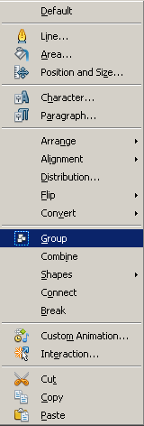

Immediately the individually selected objects are handled as one image.
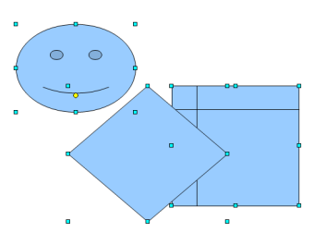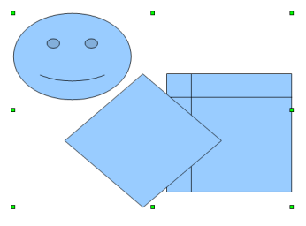
- After you have grouped objects, selecting any part of the group selects the entire group.

You can select single objects in a group by entering the group. Double-click a group to enter it and click on the object to select it.

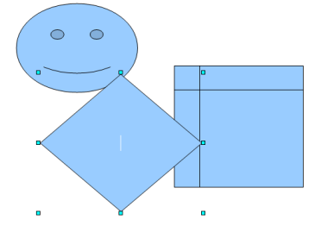
You can also add or delete objects to and from a group in this mode. The objects that are not part of the group are greyed out.

To ungroup, click on the group, right-click and choose Ungroup.

ALWAYS REMEMBER
LESS IS MORE
DO NOT OVERDO GRAPHICS
Summary

You are now able to:

- insert a graphical object into a slide
- edit a graphical object in a slide
- copy, move and delete a graphical object in a presentation and between presentations
- apply drawing tools to create images
Through completing this section you can now appreciate the value that graphics give to your presentation and how graphics can make it look more appealing than using just text.

Preparing for Output

Section Overview

How to present the BEST PRESENTATION!

This must be your motto – always the best!

We are going to look at how to finish off a presentation – set timings and transitions of slide. You are also going to look at animation on a slide. Finally, it is important to give the audience a printed copy of your slides.
By the end of this section you will be able to:
- check your slides for spelling errors
- set and change slide show timings
- create and change slide transitions
- hide and unhide some slides
- add animation effects to text and objects
- print a completed presentation
- add presenter notes to slides
- preview slides
- run the slide show

Check your Spelling

Spelling errors have a negative effect on the way an audience perceives the presentation.

There is just one rule:
NO SPELLING ERRORS!

Impress assists you by identifying spelling errors by red underlining:

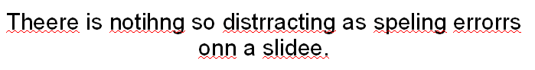

To check your spelling:

- Choose ToolsSpelling.
- The following screen assist you to correct your identified spelling errors:

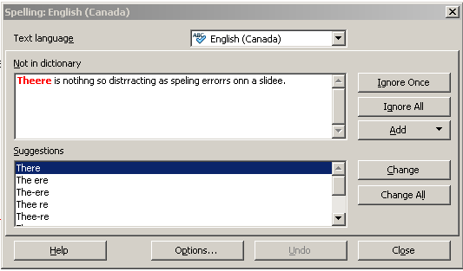
- You can:
  - Ignore Once – will ignore only this occurrence of the word
  - Ignore All – will ignore all the words in this document with the same spelling
  - Add – Add this word to your Dictionary. That means that this word will not be identified as a spelling error in future. Be careful in using this option, because if you add a wrongly spelled word, it will not be identified in future
  - Change – Change the spelling in this case to the suggestion you have identified/highlighted in the space
  - Change All – Change all the occurrences of the word in the document

Just remember, Impress will not identify if you have entered from instead of form. Both are spelled correctly.
Tip:
First run a spell check and then read carefully through your presentation to check for typos and misspelled words (has/had; from/form; like/life etc.)

Preparing your Presentation

You have now carefully constructed each slide in your presentation. The contents are clear, well presented with effective graphics to enhance key points. A very important step is now to prepare your slides for the presentation.

Slide Transitions

This will include:

- Take a good look at your slides and decide if you are going to present your slides by manually clicking or pressing the down-arrow or are you going to show your presentation with continuous running of the slides. Although the first one is always preferred by presenters, the second one can very effective when a presenter uses the presentation to create a certain mood, or when the presenter uses music to enhance the presentation. This is called TIMING.
- Decide further if there need to have transition effects between slides. This is called TRANSITION. That means that the slides are not just appearing, but have some pattern in the transition. This can be like wiping the slide off the screen to reveal another, reveal the next slide through a circle, dissolve, fade or split a slide to reveal another, to name a few. You also have to decide on the speed of this transition. The golden rule, again, is not to use too many different/complex transitions. Keep it simple not to distract the attention from the content of the presentation.

Slide Show Transitions

Many presentations contain slides that supplement a given talk. A slide is displayed and the presenter speaks to its main points. In this type of presentation, slides are usually manually advanced by the presenter only after the discussion of a slide has been exhausted and the presenter is ready to advance to the next slide. The default setting for an Impress Presentation is manual and you do not need to change anything when you want to use it.

In the event you want to automate your presentation, you do not want to manually advance to the next slide but instead want the next slide to dynamically appear after a length of time, Impress provides the ability to test rehearse timings for automatic slide changes.

To Set Automatic Timings in a Presentation

- Activate the Slide Transition menu in the Task pane.

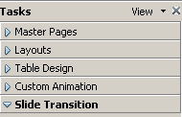

- Go to the Advance Slide section in the menu and click on the Automatically after radio button. Type in the time on each slide and Apply to All Slides.

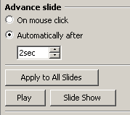

- If you want only the one slide to automatically advance, press Play button.

To Rehearse Slide Show Timings

When you rehearse timings in Impress a small floating clock window records the amount of time a slide is displayed.



During the rehearsal you could practice your speech and note the length of time during which the slide needs to remain displayed until you’re finished talking. Make a printout of the slides and note the time on each slide.

To add the timing:

- Choose Slide ShowRehearse Timings from the menu bar.

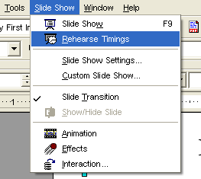

- Watch the floating clock window and record the length of time you want the current slide displayed in the presentation.
- Click the left mouse button or press the Enter key to advance and time the next slide and record the timings for that slide.
- Press the ESC key at any time to stop the Rehearse Timings clock and return to the presentation.

Setting the Duration Each Slide is Displayed

Armed with the rehearsal timings for each slide, you can then assign the timed durations to each slide in the presentation. A slide will automatically advance to the next slide based on the settings you define.

To Define Slide Duration Timings:

- Start on the first slide. Choose Slide Show Slide Transition from the menu bar.

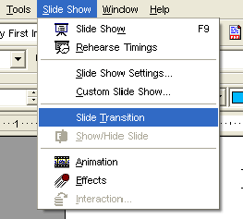

- The Slide Transition menu is displayed in the Task pane.

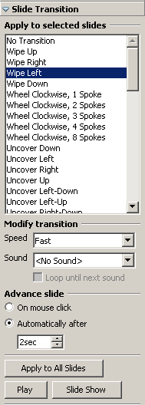
- At the bottom on the Advance Slide section, click on Automatically After and enter the time as determined in your rehersal.
- Move to the next slide and repeat until you reached the end of your presentation.
- You can now hit Play to check your timings.

Defining Slide Show Settings

Every Impress slide is governed by slide show settings, including which slide to start from, the way you advance the slides, the type of presentation, and pointer options. These settings can be changed to suit your unique presentation.

To Define Slide Show Settings:

- Choose Slide ShowSlide Show Settings from the menu bar.

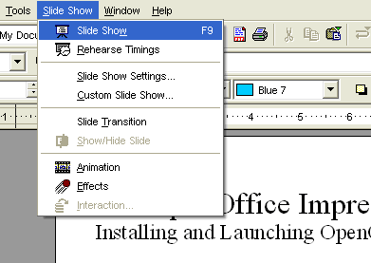

- The Slide Show dialogue box is displayed.

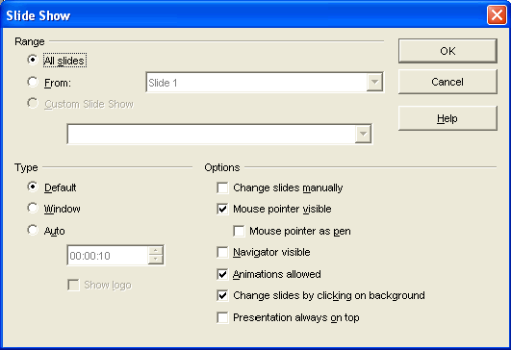

- In the Range area, specify which slides are to be included in the presentation:
  - All slides – includes all of the slides in your slide show.
  - From: – define the slide number of the start slide.
  - Custom Slide Show – runs a custom slide show in the order that you defined in Slide Show.

- Customise the slide show by selecting the slide show Type:
  - Default – a full screen slide is shown.
  - Window – slide show runs in the Impress program window.
  - Auto – define the duration of the pause before the slide show is repeated. If you enter zero, the show restarts immediately without showing a pause slide.
- Click to insert a checkmark next to any other Options to be applied to the presentation:
  - Change slides manually – slides never change automatically when this box is selected. The settings, as seen in the Transition box in the Object bar, will not apply.
  - Mouse pointer visible – shows the mouse pointer during a slide show.
  - Mouse pointer as pen – changes the mouse pointer to a pen which you can use to draw on slides during the presentation.
  - Navigator visible – displays the Navigator during the slide show.
  - Animations allowed – runs animations during the slide show. If this option is not selected, only the first frame of an animation is displayed.
  - Change slides by clicking on background – advances to the next slide when you click on the background of a slide.
  - Presentation always on top – Impress remains on top during the presentation. No other program will show its window in front of your presentation.
- Click the OK button to apply and save the definitions.

Slide Show Transitions

Once you’ve completed all of your slides, you can define slide show transitions that move from slide to slide with interesting transitions that affect the timing, entrance and exit of your slides. A transition is an effect that is applied to some or all of the slides in a presentation.

To create slide transitions:

- Choose Slide ShowSlide Transition from the menu bar.

The Slide Transition menu is displayed in the Task pane.

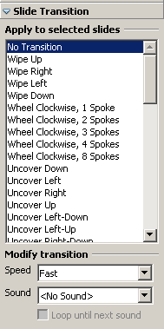

- In the effects menu scroll up and down through the selection, select one of the transition effects available for use for the slide. Effects include Fade, Fly in, Uncover, Spilt, Diagonal, Spiral and other.
- Choose the speed of transition under Modify transition.
- Choose Sound. Remember, sound can be the single most distracting factor in a presentation. Only choose when 100% necessary.
- You can do this for each separate slide (have different transitions) or press the Apply to All Slides button to apply to all slides.

Removing Transition Effects

To remove transition effects, you can reverse the above actions and choose No transition in the Slide Transition menu in the Task pane.

Animation Effects on Text and Objects

Where TRANSITION is the movement BETWEEN slides, ANIMATION is the movement of text and object ON a slide.

You can apply preset animation effects to text and objects on your slide.

The same effects that you can use for slide transitions, you can apply to text and objects on the slide.

To define animation effects on text or an object:

- On a slide, select the text box or object that you want to animate.
- Choose Slide ShowCustom Animation.

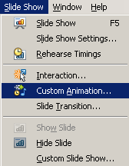
- The Custom Animation menu opens in the Task pane.

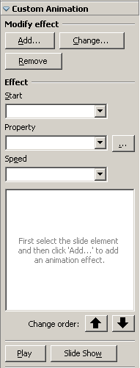

- Click on Add and choose from the box that appears. You can change the entrance of the text/object, if you want to emphasise it, the exit of the text/object, its motion path between entrance and exit and other effects. You can also adjust the speed of the animation.
- Review the effects that you want to apply to the slide(s). Remember the rule: LESS IS MORE.
- Click the OK button and then the PLAY button on the Task pane to preview the transition.

Managing the Order of Animation Effects

Assuming that you have defined multiple animation effects on one slide, you can manage or define the order in which the different text or objects are animated.

To change the order of the Animation Effects:

- Select the slide with the text/objects that you have animated.
- Activate the Custom Animation menu on the Task pane. Each one of the identified animations appears in the window. Every object or text that you animate is listed in the window in the sequence that you initially created them in.

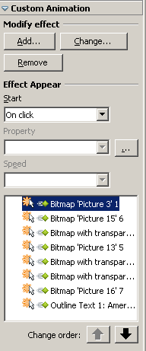
- Click the text/object you want to change the order of, click on the Change order buttons at the bottom to change the order of animation.
- Click the Play button to save the change and check the effects.

Removing Animation Effects

To remove animation effects, you can reverse the above actions by clicking and deleting the animations from the lists in the Custom Animation menu in the Task pane.

Add Presenter Notes to Slides

In the beginning of this module we have introduced you to different views in Impress (Normal, Notes, Handouts) that you can find on the Page View Buttons.

If you activate the Notes Tab, you will see each slide with a space underneath to enter notes on the above slide or to add speaker notes to the slide. Note that the notes will not appear when viewing the slides, but will only be accessible through the notes page.

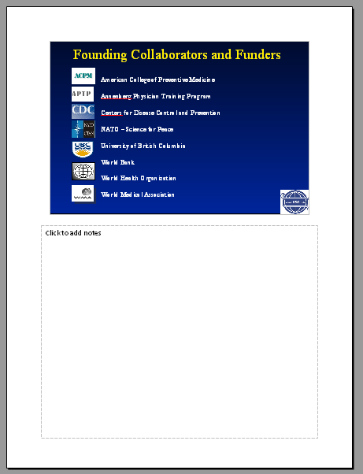
You can now add notes to the bottom of the slide by clicking on the space. A textbox will be activated. Start entering text. If you are finished, just click outside the textbox.
All the rules for text boxes apply e.g. you can format the text, change the colour or size, insert objects, charts etc.

Changing Slide Orientation and Paper Size in a Presentation

Depending on the view (normal meaning for slides, outline, notes and handout) you are in, you can change the orientation and paper size by:

- Choose FormatPage on the menu bar.
- Under Paper Format you can change:
  - Format – format of the paper e.g. letter or A4
  - Orientation – Portrait or Landscape (remember it is not good to present a slide show in portrait, but if you want to use only a print presentation, portrait can be useful).

Printing a Presentation

Printing an Impress presentation is much like printing in other OpenOffice.org applications, like Writer or Calc, or even like Microsoft Word or Microsoft Excel. Impress defaults to printing the entire presentation. However, Impress also allows you to print select slides in a presentation.

In the beginning of this module we have introduced you to different views in Impress (Normal, Notes, Handouts). You are able to print in all three formats. Check that you understand the different uses of each.

To print a presentation:

- Choose FilePrint from the menu bar.
- The Print dialog box opens.

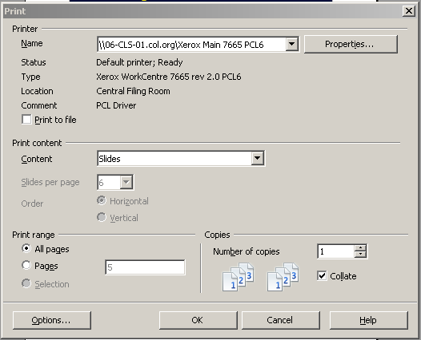

- Under Printer:
  - Specify the printer name where you want to print your presentation.
  - Add a checkmark in the Print to file field only if you are going to print the presentation to a computer file and not to a printer.

- Under Print content:
  - Select the dropdown menu for Content

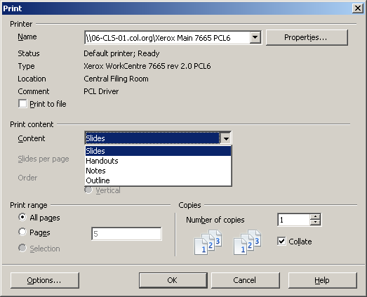

  - Choose which documents you want to print:
    - Slides
    - Handouts
    - Notes
    - Outline
- Under Print Range, choose whether you want to print All pages or a certain range of Pages, where you identify the beginning and ending page numbers, e.g. 4-8.
- Choose the Number of Copies that you want to print by clicking the up or down arrows or entering the number.
- Click the OK button to print the documents you have identified.

Only the area that you define in the print range will print when you send the presentation to the printer for printing.
Tip: In the spirit of saving paper, you might instead wish to run Print Preview instead of printing the presentation at the printer. Print Preview provides images of the printed page right on the computer monitor. This could potentially save you a lot of paper. Choose File Print Preview from the menu bar.

Running a Slide Show

Once you have formatted the presentation the way you like, and after you have timed and defined all of your settings, animations, and transitions, you can run the presentation in Slide Show format.

To run a Slide Show:

- Click Slide Show on the menu bar.

- If you have set up the presentation to advance manually, click the mouse, press the Page Down button, down arrow or press the Enter key to advance to the next slide. You can move backward one slide at a time using the Page Up button or up arrow.
- Press the Esc button at any time to exit the slide show.

Tip: If you have set the slides to advance automatically (see page 94 - 99), you don’t need to click through the slides. Just sit back and enjoy the show as the slides automatically advance according to the time sequence you have defined. At the end of the show, click the left mouse button to return to Impress.

Summary

You know now how to present the BEST PRESENTATION!

You are now able to finish off a presentation. That includes:

- checking your slides for spelling errors
- setting and changing slide show timings
- creating and changing slide transitions
- hiding and unhiding some slides
- adding animation effects to text and objects
- printing a completed presentation
- adding presenter notes to slides
- previewing slides
- running the slide show

